April 2015

Rhode Island Care Transformation Collaborative

Total Cost of Care Table and Chart Book
DRAFT

Prepared for

Rhode Island Quality Institute
50 Holden Street
Suite 300
Providence, RI 02908

Prepared by

Marianne Kluckman
Barry Eggleston
Echo Liu
Joe Burton

RTI International
3040 E. Cornwallis Road
Research Triangle Park, NC 27709

RTI Project Number 0213939

RTI Project Number
0213939

Rhode Island Care Transformation Collaborative

Total Cost of Care Table and Chart Book
DRAFT

Prepared for

Rhode Island Quality Institute
50 Holden Street
Suite 300
Providence, RI 02908

Prepared by

Marianne Kluckman
Barry Eggleston
Echo Liu
Joe Burton
RTI International
3040 E. Cornwallis Road
Research Triangle Park, NC 27709

RTI Project Number 0213939

Contents
Section Page
1. Methods 9
1.1 Assumptions 9
1.2 TCOC Measures 10
Raw TCOC 10
Risk Adjusted TCOC 10
2. Results 11
2.1 Demographics 11
2.2 Raw, Risk-Adjusted PMPM and Differences 16
2.3 Risk-Adjusted Quarterly PMPM Graphs 29
Commercial 30
Medicare Advantage 35
Rhody Health Partners 40
RIteCare 45
Medicare Fee for Service 50
Medicaid Fee for Service 54

Exhibits
Number Page
1. Risk-Adjusted Commercial Inpatient PMPM ($) Quarterly Costs for Cohort 1 and Comparison Groups with Rolling Year Trend Line 30
2. Risk-Adjusted Commercial Outpatient PMPM ($) Quarterly Costs for Cohort 1 and Comparison Groups with Rolling Year Trend Line 30
3. Risk-Adjusted Commercial Professional Services PMPM ($) Quarterly Costs for Cohort 1 and Comparison Groups with Rolling Year Trend Line 31
4. Risk-Adjusted Commercial Pharmacy PMPM ($) Quarterly Costs for Cohort 1 and Comparison Groups with Rolling Year Trend Line 31
5. Risk-Adjusted Commercial Total PMPM ($) Quarterly Costs for Cohort 1 and Comparison Groups with Rolling Year Trend Line 32
6. Risk-Adjusted Commercial Inpatient PMPM ($) Quarterly Costs for Cohort 2 and Comparison Groups with Rolling Year Trend Line 32
7. Risk-Adjusted Commercial Outpatient PMPM ($) Quarterly Costs for Cohort 2 and Comparison Groups with Rolling Year Trend Line 33
8. Risk-Adjusted Commercial Professional Services PMPM ($) Quarterly Costs for Cohort 2 and Comparison Groups with Rolling Year Trend Line 33
9. Risk-Adjusted Commercial Pharmacy PMPM ($) Quarterly Costs for Cohort 2 and Comparison Groups with Rolling Year Trend Line 34
10. Risk-Adjusted Commercial Total PMPM ($) Quarterly Costs for Cohort 2 and Comparison Groups with Rolling Year Trend Line 34
11. Risk-Adjusted Medicare Advantage Inpatient PMPM ($) Quarterly Costs for Cohort 1 and Comparison Groups with Rolling Year Trend Line 35
12. Risk-Adjusted Medicare Advantage Outpatient PMPM ($) Quarterly Costs for Cohort 1 and Comparison Groups with Rolling Year Trend Line 35
13. Risk-Adjusted Medicare Advantage Professional Services PMPM ($) Quarterly Costs for Cohort 1 and Comparison Groups with Rolling Year Trend Line 36
14. Risk-Adjusted Medicare Advantage Pharmacy PMPM ($) Quarterly Costs for Cohort 1 and Comparison Groups with Rolling Year Trend Line 36
15. Risk-Adjusted Medicare Advantage Total PMPM ($) Quarterly Costs for Cohort 1 and Comparison Groups with Rolling Year Trend Line 37
16. Risk-Adjusted Medicare Advantage Inpatient PMPM ($) Quarterly Costs for Cohort 2 and Comparison Groups with Rolling Year Trend Line 37
17. Risk-Adjusted Medicare Advantage Outpatient PMPM ($) Quarterly Costs for Cohort 2 and Comparison Groups with Rolling Year Trend Line 38
18. Risk-Adjusted Medicare Advantage Professional Services PMPM ($) Quarterly Costs for Cohort 2 and Comparison Groups with Rolling Year Trend Line 38
19. Risk-Adjusted Medicare Advantage Pharmacy PMPM ($) Quarterly Costs for Cohort 2 and Comparison Groups with Rolling Year Trend Line 39
20. Risk-Adjusted Medicare Advantage Total PMPM ($) Quarterly Costs for Cohort 2 and Comparison Groups with Rolling Year Trend Line 39
21. Risk-Adjusted RHP Inpatient PMPM ($) Quarterly Costs for Cohort 1 and Comparison Groups with Rolling Year Trend Line 40
22. Risk-Adjusted RHP Outpatient PMPM ($) Quarterly Costs for Cohort 1 and Comparison Groups with Rolling Year Trend Line 40
23. Risk-Adjusted RHP Professional Services PMPM ($) Quarterly Costs for Cohort 1 and Comparison Groups with Rolling Year Trend Line 41
24. Risk-Adjusted RHP Pharmacy PMPM ($) Quarterly Costs for Cohort 1 and Comparison Groups with Rolling Year Trend Line 41
25. Risk-Adjusted RHP Total PMPM ($) Quarterly Costs for Cohort 1 and Comparison Groups with Rolling Year Trend Line 42
26. Risk-Adjusted RHP Inpatient PMPM ($) Quarterly Costs for Cohort 2 and Comparison Groups with Rolling Year Trend Line 42
27. Risk-Adjusted RHP Outpatient PMPM ($) Quarterly Costs for Cohort 2 and Comparison Groups with Rolling Year Trend Line 43
28. Risk-Adjusted RHP Professional Services PMPM ($) Quarterly Costs for Cohort 2 and Comparison Groups with Rolling Year Trend Line 43
29. Risk-Adjusted RHP Pharmacy PMPM ($) Quarterly Costs for Cohort 2 and Comparison Groups with Rolling Year Trend Line 44
30. Risk-Adjusted RHP Total PMPM ($) Quarterly Costs for Cohort 2 and Comparison Groups with Rolling Year Trend Line 44
31. Risk-Adjusted RIteCare Inpatient PMPM ($) Quarterly Costs for Cohort 1 and Comparison Groups with Rolling Year Trend Line 45
32. Risk-Adjusted RIteCare Outpatient PMPM ($) Quarterly Costs for Cohort 1 and Comparison Groups with Rolling Year Trend Line 45
33. Risk-Adjusted RIteCare Professional Services PMPM ($) Quarterly Costs for Cohort 1 and Comparison Groups with Rolling Year Trend Line 46
34. Risk-Adjusted RIteCare Pharmacy PMPM ($) Quarterly Costs for Cohort 1 and Comparison Groups with Rolling Year Trend Line 46
35. Risk-Adjusted RIteCare Total PMPM ($) Quarterly Costs for Cohort 1 and Comparison Groups with Rolling Year Trend Line 47
36. Risk-Adjusted RIteCare Inpatient PMPM ($) Quarterly Costs for Cohort 2 and Comparison Groups with Rolling Year Trend Line 47
37. Risk-Adjusted RIteCare Outpatient PMPM ($) Quarterly Costs for Cohort 2 and Comparison Groups with Rolling Year Trend Line 48
38. Risk-Adjusted RIteCare Professional Services PMPM ($) Quarterly Costs for Cohort 2 and Comparison Groups with Rolling Year Trend Line 48
39. Risk-Adjusted RIteCare Pharmacy PMPM ($) Quarterly Costs for Cohort 2 and Comparison Groups with Rolling Year Trend Line 49
40. Risk-Adjusted RIteCare Total PMPM ($) Quarterly Costs for Cohort 2 and Comparison Groups with Rolling Year Trend Line 49
41. Risk-Adjusted Medicare FFS Inpatient PMPM ($) Quarterly Costs for Cohort 1 and Comparison Groups with Rolling Year Trend Line 50
42. Risk-Adjusted Medicare FFS Outpatient PMPM ($) Quarterly Costs for Cohort 1 and Comparison Groups with Rolling Year Trend Line 50
43. Risk-Adjusted Medicare FFS Professional Services PMPM ($) Quarterly Costs for Cohort 1 and Comparison Groups with Rolling Year Trend Line 51
44. Risk-Adjusted Medicare FFS Total PMPM ($) Quarterly Costs for Cohort 1 and Comparison Groups with Rolling Year Trend Line 51
45. Risk-Adjusted Medicare FFS Inpatient PMPM ($) Quarterly Costs for Cohort 2 and Comparison Groups with Rolling Year Trend Line 52
46. Risk-Adjusted Medicare FFS Outpatient PMPM ($) Quarterly Costs for Cohort 2 and Comparison Groups with Rolling Year Trend Line 52
47. Risk-Adjusted Medicare FFS Professional Services PMPM ($) Quarterly Costs for Cohort 2 and Comparison Groups with Rolling Year Trend Line 53
48. Risk-Adjusted Medicare FFS Total PMPM ($) Quarterly Costs for Cohort 2 and Comparison Groups with Rolling Year Trend Line 53
49. Risk-Adjusted Medicaid FFS Inpatient PMPM ($) Quarterly Costs with Rolling Year Trend Line 54
50. Risk-Adjusted Medicaid FFS Outpatient PMPM ($) Quarterly Costs with Rolling Year Trend Line 54
51. Risk-Adjusted Medicaid FFS Professional Services PMPM ($) Quarterly Costs with Rolling Year Trend Line 55
52. Risk-Adjusted Medicaid FFS Pharmacy PMPM ($) Quarterly Costs with Rolling Year Trend Line 55
53. Risk-Adjusted Medicaid FFS Total PMPM ($) Quarterly Costs with Rolling Year Trend Line 56

Tables
Number
Page
1. Demographics by payer type for 2012 CTC Cohorts and comparison groups 12
2. Demographics by payer type for 2013 CTC Cohorts and comparison groups 13
3. Demographics by payer type for 1st and 2nd Quarters of 2014 CTC Cohorts and comparison groups 14
4. Demographics by year for Medicaid FFS members 15
5. Average per member per month (PMPM) payment ($) by type of service for the RI commercially insured Cohort 1 and comparison groups 17
6. Average per member per month (PMPM) payment ($) by type of service for the RI commercially insured Cohort 2 and comparison groups 18
7. Average per member per month (PMPM) payment ($) by type of service for the RI Medicare Advantage Cohort 1 and comparison groups 19
8. Average per member per month (PMPM) payment ($) by type of service for the RI Medicare Advantage Cohort 2 and comparison groups 20
9. Average per member per month (PMPM) payment ($) by type of service for the RI Rhody Health Partners Cohort 1 and comparison groups 21
10. Average per member per month (PMPM) payment ($) by type of service for the RI Rhody Health Partners Cohort 2 and comparison groups 22
11. Average per member per month (PMPM) payment ($) by type of service for the RI RIteCare Cohort 1 and comparison groups 23
12. Average per member per month (PMPM) payment ($) by type of service for the RI RIteCare Cohort 2 and comparison groups 24
13. Average per member per month (PMPM) payment ($) by type of service for the RI Medicare FFS Cohort 1 and comparison groups 25
14. Average per member per month (PMPM) payment ($) by type of service for the RI Medicare FFS Cohort 2 and comparison groups 26
15. Average per member per month (PMPM) payment ($) by type of service for RI Medicaid FFS members 27
16. Average raw per member per month (PMPM) payment ($) for maternity services for the RI Cohort 1, Cohort 2 and comparison groups 28

1. Methods
The purpose of this report is to present the process, methodology and results in calculating Total Cost of Care (TCOC) measures for health care claims data in support of the Rhode Island Care Transformation Collaborative (CTC-RI). An evaluation of the CTC-RI program uses claims data from Blue Cross Blue Shield of Rhode Island (BCBS-RI), United Healthcare (UHC), Neighborhood Health Plan (NHP), and both Medicaid and Medicare Fee-for-Service data.

1.1 Assumptions
RTI applies the HealthPartners Total Cost of Care Methodology to the CTC dataset and include cost measures as part of the analyses. We use the Hierarchical Condition Categories (HCCs) developed for the Health Insurance Exchanges as the risk score for the purpose of risk adjustment. We also apply the current attribution algorithms to the input dataset using the following assumptions:
- Any member eligible during a quarter is included with the number of months they were eligible
- Attribution is done monthly and the attributed group (CSI, comparison, unattributed, etc.) that is the most prevalent during the quarter is chosen
- Payer type is assigned monthly and the payer type that is most prevalent during the quarter is chosen
We use all claims data that contains the needed variables to support the analyses from January 2011 through June 2014 to develop the cost measures. The cost measures are calculated for all attribution groups and are stratified by payer type, in accordance with the current utilization measures. The Total Cost of Care measures are expressed as per-member-per-month (PMPM) costs to account for differential periods of residency, insurance coverage, or tenure in an attributed practice. We also break out costs by service categories, such as inpatient (IP), outpatient (OP), professional services, and pharmacy costs.

1.2 TCOC Measures

Raw TCOC
Raw costs were adjusted for inflation using 2014 dollars by multiplying each previous year’s claims by an inflation factor as illustrated below.
Data Year | Inflation factor
2013 | 1.0218
2012 | 1.0247*1.0218
2011 | 1.03*1.0247*1.0218
These inflation adjusted total costs were then capped at $100,000 per year per member. For those members with a yearly cost exceeding $100,000 a truncation factor (100,000/total yearly costs) was applied to the individual costs for IP, OP, professional services and pharmacy costs.

Risk Adjusted TCOC
Quarterly raw costs were modeled using a two-part model where the probability of positive cost was modeled using a logistic regression model and the positive cost was modeled using a generalized linear model. Weights were applied corresponding to proportion of time an individual met the inclusion criteria. The models controlled for age, gender, risk (Hierarchical Condition Category) score, and time (to control for secular effects).

2. Results

2.1 Demographics
The following tables show, for each payer type, the demographics for the members in the CTC Cohort 1, CTC Cohort 2 and comparison groups. The “number of members” is the number of members who were attributed to that group at any time during the period shown in the table. The “number of members in the risk-adjustment model” accounts for members who were not included in the model due to missing values for either age, gender or HCC score. The “number of medical member months” is the sum of the number of months members were covered during the period. Members could be included in different groups and payer types during the year depending on their attribution. The “number of pharmacy member months” is the sum of the number of months members had prescription coverage during the period.

Table 1. Demographics by payer type for 2012 CTC Cohorts and comparison groups
 |  | Cohort 1 | Cohort 2 | Comparison
Commercial
 | Number of members | 33,232 | 43,567 | 149,778
 | Number of members in risk-adj. model | 33,231 | 43,565 | 149,771
 | Number of medical member months | 334,042 | 443,214 | 1,472,991
 | Number of pharmacy member months | 269,378 | 350,165 | 1,122,471
 | % Male | 43 | 43 | 46
 | Mean age | 45 | 46 | 44
 | Mean HCC score | 1.9 | 2.0 | 2.0
Medicare Advantage
 | Number of members | 5,767 | 10,472 | 35,348
 | Number of members in risk-adj. model | 5,767 | 10,472 | 35,348
 | Number of medical member months | 63,414 | 116,132 | 390,790
 | Number of pharmacy member months | 61,049 | 112,101 | 375,775
 | % Male | 40 | 39 | 41
 | Mean age | 73 | 74 | 75
 | Mean HCC score | 4.2 | 4.2 | 4.4
RHP
 | Number of members | 2,689 | 1,958 | 8,475
 | Number of members in risk-adj. model | 2,689 | 1,958 | 8,475
 | Number of medical member months | 24,569 | 18,224 | 81,348
 | Number of pharmacy member months | 24,189 | 18,004 | 79,778
 | % Male | 39 | 43 | 43
 | Mean age | 45 | 46 | 47
 | Mean HCC score | 3.8 | 4.5 | 4.0
RIteCare
 | Number of members | 11,253 | 8,008 | 31,728
 | Number of members in risk-adj. model | 11,253 | 8,008 | 31,728
 | Number of medical member months | 85,941 | 64,514 | 248,408
 | Number of pharmacy member months | 84,692 | 62,826 | 240,613
 | % Male | 26 | 28 | 29
 | Mean age | 31 | 33 | 32
 | Mean HCC score | 1.5 | 1.5 | 1.5
Medicare FFS
 | Number of members | 7,096 | 9,535 | 33,453
 | Number of members in risk-adj. model | 7,093 | 9,529 | 33,418
 | Number of medical member months | 74,237 | 102,630 | 356,720
 | Number of pharmacy member months | 0 | 0 | 0
 | % Male | 41 | 42 | 42
 | Mean age | 72 | 72 | 72
 | Mean HCC score | 4.6 | 4.6 | 4.9

Table 2. Demographics by payer type for 2013 CTC Cohorts and comparison groups

 |  | Cohort 1 | Cohort 2 | Comparison
Commercial
 | Number of members | 34,773 | 44,686 | 152,986
 | Number of members in risk-adj. model | 34,771 | 44,685 | 152,979
 | Number of medical member months | 344,643 | 449,792 | 1,469,471
 | Number of pharmacy member months | 281,434 | 358,286 | 1,139,242
 | % Male | 43 | 43 | 47
 | Mean age | 45 | 46 | 44
 | Mean HCC score | 2.0 | 2.2 | 2.1
Medicare Advantage
 | Number of members | 6,461 | 10,725 | 36,986
 | Number of members in risk-adj. model | 6,461 | 10,725 | 36,986
 | Number of medical member months | 68,375 | 118,131 | 383,618
 | Number of pharmacy member months | 66,200 | 114,713 | 370,677
 | % Male | 40 | 39 | 41
 | Mean age | 73 | 74 | 75
 | Mean HCC score | 4.5 | 4.8 | 5.1
RHP
 | Number of members | 2,973 | 2,043 | 8,664
 | Number of members in risk-adj. model | 2,973 | 2,043 | 8,664
 | Number of medical member months | 27,271 | 19,077 | 80,757
 | Number of pharmacy member months | 27,105 | 18,965 | 79,920
 | % Male | 39 | 44 | 45
 | Mean age | 45 | 46 | 47
 | Mean HCC score | 3.9 | 4.6 | 4.3
RIteCare
 | Number of members | 12,058 | 8,429 | 32,108
 | Number of members in risk-adj. model | 12,058 | 8,429 | 32,108
 | Number of medical member months | 97,659 | 68,207 | 247,697
 | Number of pharmacy member months | 96,081 | 66,085 | 237,574
 | % Male | 26 | 28 | 29
 | Mean age | 32 | 33 | 32
 | Mean HCC score | 1.5 | 1.6 | 1.5
Medicare FFS
 | Number of members | 7,891 | 10,552 | 35,648
 | Number of members in risk-adj. model | 7,890 | 10,547 | 35,627
 | Number of medical member months | 82,649 | 114,744 | 374,917
 | Number of pharmacy member months | 0 | 0 | 0
 | % Male | 41 | 42 | 43
 | Mean age | 72 | 72 | 72
 | Mean HCC score | 5.0 | 5.0 | 5.3

Table 3. Demographics by payer type for 1st and 2nd Quarters of 2014 CTC Cohorts and comparison groups
 |  | Cohort 1 | Cohort 2 | Comparison
Commercial
 | Number of members | 32,184 | 40,923 | 129,743
 | Number of members in risk-adj. model | 32,183 | 40,922 | 129,741
 | Number of medical member months | 176,130 | 226,435 | 698,301
 | Number of pharmacy member months | 143,888 | 180,812 | 542,370
 | % Male | 43 | 43 | 47
 | Mean age | 46 | 47 | 45
 | Mean HCC score | 2.1 | 2.3 | 2.2
Medicare Advantage
 | Number of members | 6,808 | 11,165 | 36,071
 | Number of members in risk-adj. model | 6,808 | 11,165 | 36,071
 | Number of medical member months | 32,325 | 54,364 | 167,059
 | Number of pharmacy member months | 31,843 | 53,505 | 164,096
 | % Male | 40 | 39 | 41
 | Mean age | 73 | 74 | 75
 | Mean HCC score | 5.0 | 5.4 | 5.5
RHP
 | Number of members | 2,591 | 1,836 | 6,907
 | Number of members in risk-adj. model | 2,591 | 1,836 | 6,907
 | Number of medical member months | 14,099 | 9,697 | 37,900
 | Number of pharmacy member months | 14,099 | 9,697 | 37,897
 | % Male | 39 | 46 | 45
 | Mean age | 45 | 46 | 47
 | Mean HCC score | 4.7 | 5.0 | 4.8
RIteCare
 | Number of members | 18,764 | 16,859 | 45,924
 | Number of members in risk-adj. model | 18,764 | 16,859 | 45,924
 | Number of medical member months | 82,179 | 65,680 | 201,801
 | Number of pharmacy member months | 82,164 | 65,663 | 201,703
 | % Male | 36 | 42 | 38
 | Mean age | 35 | 37 | 35
 | Mean HCC score | 1.2 | 1.2 | 1.2
Medicare FFS
 | Number of members | 7,519 | 10,464 | 32,203
 | Number of members in risk-adj. model | 7,519 | 10,464 | 32,203
 | Number of medical member months | 42,766 | 59,928 | 182,411
 | Number of pharmacy member months | 0 | 0 | 0
 | % Male | 41 | 42 | 43
 | Mean age | 72 | 73 | 73
 | Mean HCC score | 5.6 | 5.9 | 6.4

Table 4. Demographics by year for Medicaid FFS members
 |  | 2012 | 2013 | 1Q2014
Medicaid FFS
 | Number of members | 53,922 | 46,005 | 32,658
 | Number of members in risk-adj. model | 53,922 | 46,005 | 32,658
 | Number of medical member months | 265,768 | 183,325 | 57,772
 | Number of pharmacy member months | 265,768 | 183,325 | 57,772
 | % Male | 34 | 33 | 38
 | Mean age | 45 | 42 | 36
 | Mean HCC score | 1.8 | 1.6 | 1.0

2.2 Raw, Risk-Adjusted PMPM and Differences

The following tables show, for each payer type, the raw and risk-adjusted annual PMPM values for the members in the CTC Cohort 1, CTC Cohort 2 and comparison groups. The difference between the two groups is shown along with its 95% confidence interval. The p-value for the difference is also displayed for each individual service component. Please note that a p-value less than 0.05 may be interpreted as a statistically significant difference, but a lack of significance does not mean there was no difference, it just means no conclusion can be made. Also, reported differences in PMPM values may differ from visually calculated PMPM differences because of rounding. Total PMPM values are the sum of the results from the individual service components PMPM values.
.
Table 5. Average per member per month (PMPM) payment ($) by type of service for the RI commercially insured Cohort 1 and comparison groups

 |  | Cohort 1 |  | Comparison |  |  | Difference
 |  | Raw PMPM | Risk-Adjusted PMPM | Raw PMPM | Risk-Adjusted PMPM | Raw  PMPM  (95% CI) |  | P-value | Risk-Adjusted PMPM  (95 % CI) | P-value
Inpatient Costs
 | 2011 | 80 | 78 | 88 | 87 | -8 (-14,-2) |  | 0.01 | -9 (-15,-3) | <0.01
 | 2012 | 79 | 78 | 88 | 87 | -9 (-15,-3) |  | <0.01 | -10 (-15,-4) | <0.01
 | 2013 | 81 | 81 | 82 | 82 | -1 (-7,5) |  | 0.75 | -1 (-7,5) | 0.78
 | 1Q-2Q2014 | 83 | 85 | 85 | 85 | -2 (-10,6) |  | 0.65 | 0 (-9,9) | 1.00
Outpatient Costs
 | 2011 | 125 | 126 | 126 | 126 | -1 (-5,4) |  | 0.78 | 1 (-6,8) | 0.83
 | 2012 | 122 | 122 | 126 | 126 | -3 (-7,0) |  | 0.07 | -4 (-10,3) | 0.25
 | 2013 | 125 | 124 | 127 | 125 | -1 (-5,3) |  | 0.50 | -1 (-7,5) | 0.66
 | 1Q-2Q2014 | 127 | 126 | 131 | 129 | -4 (-10,2) |  | 0.21 | -3 (-12,6) | 0.48
Professional Services Costs
 | 2011 | 177 | 176 | 174 | 175 | 3 (0,6) |  | 0.04 | 1 (-3,6) | 0.58
 | 2012 | 168 | 167 | 164 | 164 | 4 (1,6) |  | 0.01 | 3 (-1,7) | 0.18
 | 2013 | 164 | 163 | 156 | 155 | 8 (6,11) |  | <0.01 | 9 (5,12) | <0.01
 | 1Q-2Q2014 | 161 | 160 | 153 | 152 | 8 (4,11) |  | <0.01 | 8 (3,13) | <0.01
Pharmacy Costs
 | 2011 | 127 | 123 | 141 | 134 | -14 (-17,-11) |  | <0.01 | -11 (-17,-4) | <0.01
 | 2012 | 118 | 118 | 128 | 124 | -10 (-13,-7) |  | <0.01 | -5 (-12,1) | 0.12
 | 2013 | 104 | 108 | 111 | 112 | -7 (-9,-4) |  | <0.01 | -3 (-10,4) | 0.34
 | 1Q-2Q2014 | 96 | 105 | 108 | 115 | -12 (-16,-7) |  | <0.01 | -10 (-18,-1) | 0.03
Total Costs
 | 2011 | 509 | 504 | 529 | 522 | -20 |  |  | -18
 | 2012 | 487 | 485 | 505 | 501 | -19 |  |  | -16
 | 2013 | 475 | 477 | 476 | 474 | -1 |  |  | 3
 | 1Q-2Q2014 | 467 | 476 | 476 | 481 | -9 |  |  | -5

Table 6. Average per member per month (PMPM) payment ($) by type of service for the RI commercially insured Cohort 2 and comparison groups
 |  | Cohort 2 |  | Comparison |  | Difference
 |  | Raw PMPM | Risk-Adjusted PMPM | Raw PMPM | Risk-Adjusted PMPM | Raw  PMPM  (95% CI) | P-value | Risk-Adjusted PMPM  (95 % CI) | P-value
Inpatient Costs
 | 2011 | 82 | 82 | 88 | 87 | -6 (-12,-1) | 0.02 | -6 (-11,0) | 0.05
 | 2012 | 88 | 87 | 88 | 87 | 0 (-5,5) | 0.96 | 0 (-6,5) | 0.91
 | 2013 | 83 | 83 | 82 | 82 | 1 (-4,6) | 0.66 | 1 (-5,6) | 0.83
 | 1Q-2Q2014 | 87 | 88 | 85 | 85 | 2 (-6,10) | 0.63 | 3 (-5,11) | 0.44
Outpatient Costs
 | 2011 | 130 | 131 | 126 | 126 | 4 (0,7) | 0.06 | 5 (-1,11) | 0.10
 | 2012 | 132 | 133 | 126 | 126 | 6 (2,10) | <0.01 | 7 (2,13) | 0.01
 | 2013 | 130 | 129 | 127 | 125 | 3 (0,7) | 0.09 | 3 (-2,9) | 0.24
 | 1Q-2Q2014 | 132 | 131 | 131 | 129 | 1 (-4,7) | 0.66 | 2 (-6,10) | 0.67
Professional Services Costs
 | 2011 | 188 | 187 | 174 | 175 | 14 (12,17) | <0.01 | 12 (8,16) | <0.01
 | 2012 | 179 | 178 | 164 | 164 | 15 (13,17) | <0.01 | 14 (10,17) | <0.01
 | 2013 | 173 | 172 | 156 | 155 | 17 (14,19) | <0.01 | 17 (14,21) | <0.01
 | 1Q-2Q2014 | 166 | 165 | 153 | 152 | 13 (10,16) | <0.01 | 13 (8,17) | <0.01
Pharmacy Costs
 | 2011 | 136 | 134 | 141 | 134 | -5 (-8,-2) | <0.01 | 0 (-7,7) | 0.99
 | 2012 | 126 | 126 | 128 | 124 | -2 (-5,1) | 0.15 | 2 (-5,8) | 0.56
 | 2013 | 113 | 117 | 111 | 112 | 2 (-1,4) | 0.27 | 5 (-1,12) | 0.12
 | 1Q-2Q2014 | 105 | 113 | 108 | 115 | -3 (-7,1) | 0.14 | -2 (-10,6) | 0.65
Total Costs
 | 2011 | 535 | 533 | 529 | 522 | 7 |  | 12
 | 2012 | 525 | 524 | 505 | 501 | 19 |  | 23
 | 2013 | 498 | 501 | 476 | 474 | 22 |  | 27
 | 1Q-2Q2014 | 489 | 496 | 476 | 481 | 13 |  | 16

Table 7. Average per member per month (PMPM) payment ($) by type of service for the RI Medicare Advantage Cohort 1 and comparison groups
 |  | Cohort 1 |  | Comparison |  | Difference
 |  | Raw PMPM | Risk-Adjusted PMPM | Raw PMPM | Risk-Adjusted PMPM | Raw  PMPM  (95% CI) | P-value | Risk-Adjusted PMPM  (95% CI) | P-value
Inpatient Costs
 | 2011 | 224 | 222 | 239 | 241 | -15 (-35,5) | 0.14 | -18 (-39,3) | 0.09
 | 2012 | 232 | 233 | 269 | 269 | -37 (-58,-17) | <0.01 | -37 (-58,-15) | <0.01
 | 2013 | 223 | 222 | 277 | 278 | -54 (-73,-36) | <0.01 | -56 (-75,-36) | <0.01
 | 1Q-2Q2014 | 202 | 202 | 233 | 235 | -32 (-59,-4) | 0.02 | -33 (-61,-4) | 0.02
Outpatient Costs
 | 2011 | 127 | 123 | 129 | 126 | -2 (-10,6) | 0.65 | -3 (-15,9) | 0.62
 | 2012 | 144 | 147 | 148 | 150 | -4 (-12,5) | 0.40 | -3 (-17,10) | 0.65
 | 2013 | 135 | 137 | 136 | 138 | -1 (-9,7) | 0.85 | -1 (-13,12) | 0.88
 | 1Q-2Q2014 | 112 | 115 | 126 | 128 | -14 (-25,-3) | 0.01 | -12 (-27,3) | 0.11
Professional Services Costs
 | 2011 | 202 | 201 | 203 | 201 | -1 (-9,6) | 0.78 | 0 (-13,12) | 0.95
 | 2012 | 236 | 239 | 242 | 244 | -6 (-14,2) | 0.13 | -5 (-18,8) | 0.47
 | 2013 | 249 | 252 | 251 | 251 | -1 (-9,6) | 0.71 | 1 (-12,14) | 0.90
 | 1Q-2Q2014 | 184 | 190 | 203 | 205 | -19 (-27,-11) | <0.01 | -16 (-27,-4) | 0.01
Pharmacy Costs
 | 2011 | 199 | 199 | 209 | 202 | -10 (-16,-3) | <0.01 | -4 (-19,11) | 0.63
 | 2012 | 192 | 199 | 196 | 190 | -4 (-11,2) | 0.20 | 9 (-9,27) | 0.34
 | 2013 | 177 | 192 | 183 | 184 | -6 (-12,0) | 0.07 | 8 (-10,27) | 0.39
 | 1Q-2Q2014 | 172 | 189 | 175 | 181 | -2 (-14,9) | 0.67 | 7 (-13,28) | 0.48
Total Costs
 | 2011 | 752 | 745 | 780 | 770 | -28 |  | -25
 | 2012 | 804 | 817 | 855 | 853 | -51 |  | -36
 | 2013 | 784 | 802 | 847 | 850 | -63 |  | -47
 | 1Q-2Q2014 | 670 | 696 | 737 | 749 | -67 |  | -53

Table 8. Average per member per month (PMPM) payment ($) by type of service for the RI Medicare Advantage Cohort 2 and comparison groups
 |  |  | Cohort 2 |  | Comparison |  | Difference
 |  |  | Raw PMPM | Risk-Adjusted PMPM | Raw PMPM | Risk-Adjusted PMPM | Raw  PMPM  (95% CI) | P-value | Risk-Adjusted PMPM  (95% CI) | P-value
Inpatient Costs
 | 2011 |  | 229 | 230 | 239 | 241 | -10 (-26,5) | 0.2 | -11 (-27,6) | 0.22
 | 2012 |  | 280 | 283 | 269 | 269 | 12 (-6,29) | 0.21 | 13 (-6,32) | 0.16
 | 2013 |  | 265 | 265 | 277 | 278 | -12 (-29,5) | 0.18 | -13 (-31,5) | 0.16
 | 1Q-2Q2014 |  | 223 | 223 | 233 | 235 | -10 (-33,13) | 0.40 | -12 (-35,12) | 0.34
Outpatient Costs
 | 2011 |  | 134 | 129 | 129 | 126 | 4 (-2,11) | 0.18 | 3 (-7,12) | 0.58
 | 2012 |  | 151 | 153 | 148 | 150 | 3 (-4,10) | 0.45 | 3 (-9,14) | 0.64
 | 2013 |  | 133 | 135 | 136 | 138 | -3 (-9,3) | 0.32 | -3 (-14,8) | 0.59
 | 1Q-2Q2014 |  | 127 | 130 | 126 | 128 | 1 (-8,10) | 0.82 | 2 (-11,16) | 0.73
Professional Services Costs
 | 2011 | 199 |  | 196 | 203 | 201 | -4 (-9,2) | 0.17 | -5 (-15,5) | 0.29
 | 2012 | 231 |  | 229 | 242 | 244 | -12 (-17,-6) | <0.01 | -14 (-24,-5) | <0.01
 | 2013 | 249 |  | 246 | 251 | 251 | -1 (-7,5) | 0.66 | -5 (-14,5) | 0.32
 | 1Q-2Q2014 | 205 |  | 211 | 203 | 205 | 2 (-5,10) | 0.57 | 6 (-6,17) | 0.32
Pharmacy Costs
 | 2011 | 198 |  | 193 | 209 | 202 | -11 (-15,-6) | <0.01 | -9 (-20,2) | 0.1
 | 2012 | 187 |  | 185 | 196 | 190 | -10 (-14,-5) | <0.01 | -5 (-16,6) | 0.36
 | 2013 | 179 |  | 185 | 183 | 184 | -4 (-9,1) | 0.13 | 1 (-11,14) | 0.84
 | 1Q-2Q2014 | 173 |  | 183 | 175 | 181 | -1 (-10,7) | 0.74 | 2 (-13,17) | 0.79
Total Costs
 | 2011 | 759 |  | 748 | 780 | 770 | -21 |  | -23
 | 2012 | 848 |  | 849 | 855 | 853 | -7 |  | -3
 | 2013 | 827 |  | 830 | 847 | 850 | -20 |  | -20
 | 1Q-2Q2014 | 729 |  | 747 | 737 | 749 | -8 |  | -2

Table 9. Average per member per month (PMPM) payment ($) by type of service for the RI Rhody Health Partners Cohort 1 and comparison groups
 |  | Cohort 1 |  | Comparison |  | Difference
 |  | Raw PMPM | Risk-Adjusted PMPM | Raw PMPM | Risk-Adjusted PMPM | Raw  PMPM  (95% CI) | P-value | Risk-Adjusted PMPM  (95% CI) | P-value
Inpatient Costs
 | 2011 | 203 | 202 | 194 | 193 | 9 (-23,42) | 0.58 | 9 (-25,44) | 0.60
 | 2012 | 181 | 176 | 199 | 199 | -18 (-48,11) | 0.23 | -24 (-54,7) | 0.13
 | 2013 | 177 | 178 | 221 | 219 | -43 (-72,-15) | <0.01 | -41 (-71,-11) | 0.01
 | 1Q-2Q2014 | 218 | 215 | 253 | 256 | -35 (-83,13) | 0.16 | -41 (-91,9) | 0.11
Outpatient Costs
 | 2011 | 241 | 240 | 194 | 190 | 47 (25,69) | <0.01 | 49 (14,85) | 0.01
 | 2012 | 250 | 249 | 207 | 203 | 43 (23,63) | <0.01 | 46 (11,81) | 0.01
 | 2013 | 233 | 231 | 212 | 208 | 21 (3,39) | 0.02 | 24 (-5,52) | 0.11
 | 1Q-2Q2014 | 215 | 222 | 209 | 213 | 6 (-21,33) | 0.65 | 9 (-35,53) | 0.68
Professional Services Costs
 | 2011 | 162 | 158 | 129 | 128 | 33 (22,44) | <0.01 | 30 (10,50) | <0.01
 | 2012 | 162 | 160 | 145 | 145 | 17 (7,28) | <0.01 | 15 (-5,36) | 0.14
 | 2013 | 178 | 179 | 168 | 165 | 10 (-1,21) | 0.08 | 13 (-12,39) | 0.30
 | 1Q-2Q2014 | 178 | 178 | 178 | 177 | 0 (-14,15) | 0.94 | 0 (-27,27) | 0.99
Pharmacy Costs
 | 2011 | 307 | 291 | 263 | 259 | 43 (23,63) | <0.01 | 32 (-3,67) | 0.08
 | 2012 | 260 | 250 | 249 | 248 | 11 (-5,26) | 0.18 | 2 (-27,31) | 0.90
 | 2013 | 240 | 230 | 255 | 259 | -15 (-28,-2) | 0.02 | -29 (-55,-3) | 0.03
 | 1Q-2Q2014 | 272 | 271 | 271 | 296 | 2 (-34,37) | 0.93 | -24 (-76,28) | 0.36
Total Costs
 | 2011 | 913 | 890 | 780 | 769 | 133 |  | 121
 | 2012 | 853 | 835 | 800 | 796 | 53 |  | 40
 | 2013 | 827 | 818 | 855 | 851 | -28 |  | -33
 | 1Q-2Q2014 | 883 | 886 | 910 | 942 | -26 |  | -56

Table 10. Average per member per month (PMPM) payment ($) by type of service for the RI Rhody Health Partners Cohort 2 and comparison groups
 |  | Cohort 2 |  | Comparison |  | Difference
 |  | Raw PMPM | Risk-Adjusted PMPM | Raw PMPM | Risk-Adjusted PMPM | Raw  PMPM  (95% CI) | P-value | Risk-Adjusted PMPM  (95% CI) | P-value
Inpatient Costs
 | 2011 | 199 | 202 | 194 | 193 | 5 (-33,43) | 0.81 | 10 (-32,52) | 0.65
 | 2012 | 215 | 220 | 199 | 199 | 15 (-22,53) | 0.43 | 20 (-21,61) | 0.34
 | 2013 | 231 | 234 | 221 | 219 | 10 (-27,48) | 0.59 | 15 (-27,58) | 0.48
 | 1Q-2Q2014 | 270 | 276 | 253 | 256 | 18 (-48,84) | 0.60 | 20 (-49,89) | 0.57
Outpatient Costs
 | 2011 | 220 | 215 | 194 | 190 | 26 (1,52) | 0.04 | 25 (-14,64) | 0.21
 | 2012 | 265 | 261 | 207 | 203 | 58 (29,86) | <0.01 | 58 (13,103) | 0.01
 | 2013 | 275 | 285 | 212 | 208 | 64 (34,93) | <0.01 | 77 (28,126) | <0.01
 | 1Q-2Q2014 | 265 | 296 | 209 | 213 | 56 (12,100) | 0.01 | 82 (7,158) | 0.03
Professional Services Costs
 | 2011 | 156 | 159 | 129 | 128 | 27 (12,41) | <0.01 | 32 (-1,65) | 0.06
 | 2012 | 175 | 173 | 145 | 145 | 30 (15,45) | <0.01 | 28 (-4,60) | 0.08
 | 2013 | 189 | 188 | 168 | 165 | 21 (8,35) | <0.01 | 22 (-7,52) | 0.13
 | 1Q-2Q2014 | 198 | 185 | 178 | 177 | 20 (3,37) | 0.02 | 8 (-16,32) | 0.53
Pharmacy Costs
 | 2011 | 337 | 321 | 263 | 259 | 74 (49,99) | <0.01 | 62 (17,107) | 0.01
 | 2012 | 298 | 287 | 249 | 248 | 49 (30,67) | <0.01 | 38 (2,75) | 0.04
 | 2013 | 282 | 271 | 255 | 259 | 26 (10,43) | <0.01 | 12 (-21,45) | 0.46
 | 1Q-2Q2014 | 286 | 280 | 271 | 296 | 15 (-19,49) | 0.39 | -16 (-65,34) | 0.53
Total Costs
 | 2011 | 912 | 898 | 780 | 769 | 132 |  | 129
 | 2012 | 952 | 940 | 800 | 796 | 152 |  | 144
 | 2013 | 977 | 978 | 855 | 851 | 122 |  | 127
 | 1Q-2Q2014 | 1019 | 1037 | 910 | 942 | 109 |  | 95

Table 11. Average per member per month (PMPM) payment ($) by type of service for the RI RIteCare Cohort 1 and comparison groups
 |  | Cohort 1 |  | Comparison |  | Difference
 |  | Raw PMPM | Risk-Adjusted PMPM | Raw PMPM | Risk-Adjusted PMPM | Raw  PMPM  (95% CI) | P-value | Risk-Adjusted PMPM  (95% CI) | P-value
Inpatient Costs
 | 2011 | 76 | 77 | 69 | 71 | 7 (-1,15) | 0.09 | 6 (-3,14) | 0.23
 | 2012 | 69 | 69 | 65 | 66 | 3 (-3,10) | 0.31 | 4 (-4,11) | 0.33
 | 2013 | 65 | 64 | 62 | 63 | 3 (-3,9) | 0.39 | 0 (-6,7) | 0.94
 | 1Q-2Q2014 | 78 | 71 | 69 | 66 | 9 (-1,19) | 0.06 | 6 (-4,16) | 0.26
Outpatient Costs
 | 2011 | 111 | 112 | 102 | 101 | 10 (5,15) | <0.01 | 10 (2,18) | 0.01
 | 2012 | 110 | 108 | 102 | 100 | 9 (4,13) | <0.01 | 8 (2,15) | 0.01
 | 2013 | 104 | 102 | 97 | 96 | 6 (3,10) | <0.01 | 6 (1,12) | 0.02
 | 1Q-2Q2014 | 120 | 118 | 104 | 102 | 16 (9,23) | <0.01 | 16 (7,25) | <0.01
Professional Services Costs
 | 2011 | 96 | 95 | 90 | 89 | 6 (3,10) | <0.01 | 6 (2,11) | <0.01
 | 2012 | 95 | 94 | 92 | 92 | 3 (0,6) | 0.04 | 3 (-2,7) | 0.24
 | 2013 | 94 | 93 | 99 | 98 | -5 (-8,-2) | <0.01 | -6 (-10,-1) | 0.02
 | 1Q-2Q2014 | 101 | 100 | 99 | 98 | 2 (-2,5) | 0.3 | 3 (-2,7) | 0.28
Pharmacy Costs
 | 2011 | 51 | 45 | 49 | 46 | 2 (-1,4) | 0.2 | 0 (-5,5) | 0.89
 | 2012 | 53 | 51 | 50 | 47 | 2 (-1,6) | 0.12 | 3 (-4,11) | 0.39
 | 2013 | 52 | 52 | 48 | 47 | 4 (1,7) | 0.01 | 5 (-2,13) | 0.17
 | 1Q-2Q2014 | 50 | 48 | 40 | 40 | 10 (7,13) | <0.01 | 8 (3,14) | 0.01
Total Costs
 | 2011 | 335 | 329 | 310 | 307 | 25 |  | 22
 | 2012 | 327 | 323 | 310 | 305 | 18 |  | 18
 | 2013 | 314 | 310 | 307 | 304 | 8 |  | 6
 | 1Q-2Q2014 | 349 | 338 | 312 | 305 | 37 |  | 33

Table 12. Average per member per month (PMPM) payment ($) by type of service for the RI RIteCare Cohort 2 and comparison groups
 |  | Cohort 2 |  | Comparison |  | Difference
 |  | Raw PMPM | Risk-Adjusted PMPM | Raw PMPM | Risk-Adjusted PMPM | Raw  PMPM  (95% CI) | P-value | Risk-Adjusted PMPM  (95% CI) | P-value
Inpatient Costs
 | 2011 | 67 | 65 | 69 | 71 | -3 (-11,6) | 0.53 | -6 (-16,3) | 0.21
 | 2012 | 61 | 62 | 65 | 66 | -5 (-13,3) | 0.25 | -4 (-14,6) | 0.43
 | 2013 | 65 | 64 | 62 | 63 | 3 (-5,11) | 0.48 | 0 (-9,10) | 0.92
 | 1Q-2Q2014 | 73 | 63 | 69 | 66 | 4 (-6,15) | 0.42 | -2 (-13,8) | 0.65
Outpatient Costs
 | 2011 | 104 | 105 | 102 | 101 | 2 (-4,9) | 0.43 | 4 (-6,13) | 0.43
 | 2012 | 108 | 109 | 102 | 100 | 6 (0,12) | 0.04 | 9 (0,18) | 0.05
 | 2013 | 103 | 104 | 97 | 96 | 6 (1,11) | 0.02 | 8 (0,17) | 0.06
 | 1Q-2Q2014 | 107 | 104 | 104 | 102 | 3 (-3,10) | 0.32 | 1 (-7,10) | 0.77
Professional Services Costs
 | 2011 | 91 | 90 | 90 | 89 | 1 (-2,4) | 0.67 | 1 (-3,5) | 0.58
 | 2012 | 91 | 90 | 92 | 92 | -1 (-4,2) | 0.60 | -1 (-6,3) | 0.56
 | 2013 | 98 | 98 | 99 | 98 | 0 (-4,3) | 0.83 | -1 (-5,4) | 0.79
 | 1Q-2Q2014 | 99 | 98 | 99 | 98 | 0 (-4,3) | 0.95 | 0 (-5,4) | 0.95
Pharmacy Costs
 | 2011 | 64 | 59 | 49 | 46 | 15 (11,18) | <0.01 | 14 (6,21) | <0.01
 | 2012 | 63 | 59 | 50 | 47 | 13 (10,16) | <0.01 | 11 (3,19) | 0.01
 | 2013 | 64 | 60 | 48 | 47 | 16 (12,20) | <0.01 | 13 (4,22) | <0.01
 | 1Q-2Q2014 | 55 | 50 | 40 | 40 | 15 (11,20) | <0.01 | 11 (3,18) | 0.01
Total Costs
 | 2011 | 325 | 320 | 310 | 307 | 15 |  | 12
 | 2012 | 323 | 320 | 310 | 305 | 13 |  | 15
 | 2013 | 331 | 325 | 307 | 304 | 24 |  | 21
 | 1Q-2Q2014 | 334 | 315 | 312 | 305 | 23 |  | 9

Table 13. Average per member per month (PMPM) payment ($) by type of service for the RI Medicare FFS Cohort 1 and comparison groups
 |  | Cohort 1 |  | Comparison |  | Difference
 |  | Raw PMPM | Risk-Adjusted PMPM | Raw PMPM | Risk-Adjusted PMPM | Raw  PMPM  (95% CI) | P-value | Risk-Adjusted PMPM  (95% CI) | P-value
Inpatient Costs
 | 2011 | 284 | 284 | 228 | 228 | 56 (32,79) | <0.01 | 56 (31,81) | <0.01
 | 2012 | 329 | 329 | 239 | 240 | 90 (65,115) | <0.01 | 89 (63,116) | <0.01
 | 2013 | 278 | 279 | 260 | 260 | 18 (-3,40) | 0.09 | 19 (-4,41) | 0.10
 | 1Q-2Q2014 | 277 | 277 | 338 | 339 | -61 (-90,-31) | <0.01 | -62 (-92,-31) | <0.01
Outpatient Costs
 | 2011 | 149 | 146 | 132 | 135 | 17 (8,25) | <0.01 | 11 (2,20) | 0.02
 | 2012 | 155 | 154 | 147 | 148 | 9 (1,17) | 0.03 | 6 (-3,15) | 0.22
 | 2013 | 162 | 158 | 165 | 163 | -3 (-11,5) | 0.53 | -4 (-13,4) | 0.30
 | 1Q-2Q2014 | 171 | 169 | 176 | 173 | -5 (-17,7) | 0.39 | -4 (-16,8) | 0.53
Professional Services Costs
 | 2011 | 331 | 335 | 301 | 299 | 30 (21,38) | <0.01 | 35 (22,48) | <0.01
 | 2012 | 313 | 316 | 295 | 292 | 18 (11,25) | <0.01 | 25 (13,37) | <0.01
 | 2013 | 321 | 329 | 314 | 314 | 7 (0,14) | 0.06 | 15 (3,28) | 0.01
 | 1Q-2Q2014 | 317 | 324 | 326 | 333 | -9 (-20,1) | 0.07 | -8 (-23,7) | 0.28
Total Costs
 | 2011 | 763 | 765 | 661 | 663 | 102 |  | 103
 | 2012 | 797 | 800 | 681 | 680 | 116 |  | 120
 | 2013 | 762 | 766 | 739 | 736 | 23 |  | 30
 | 1Q-2Q2014 | 765 | 771 | 840 | 844 | -75 |  | -74

Table 14. Average per member per month (PMPM) payment ($) by type of service for the RI Medicare FFS Cohort 2 and comparison groups
 |  |  | Cohort 2 |  | Comparison |  | Difference
 |  |  | Raw PMPM | Risk-Adjusted PMPM | Raw PMPM | Risk-Adjusted PMPM | Raw  PMPM  (95% CI) | P-value | Risk-Adjusted PMPM  (95% CI) | P-value
Inpatient Costs
 | 2011 | 214 |  | 214 | 228 | 228 | -14 (-30,3) | 0.11 | -15 (-32,3) | 0.10
 | 2012 | 224 |  | 224 | 239 | 240 | -16 (-33,1) | 0.07 | -16 (-34,2) | 0.08
 | 2013 | 239 |  | 240 | 260 | 260 | -21 (-37,-4) | 0.01 | -20 (-37,-3) | 0.02
 | 1Q-2Q2014 | 307 |  | 310 | 338 | 339 | -31 (-58,-4) | 0.03 | -28 (-57,0) | 0.05
Outpatient Costs
 | 2011 | 128 |  | 133 | 132 | 135 | -4 (-11,2) | 0.20 | -2 (-10,6) | 0.60
 | 2012 | 139 |  | 140 | 147 | 148 | -7 (-14,0) | 0.04 | -8 (-15,-1) | 0.03
 | 2013 | 153 |  | 152 | 165 | 163 | -11 (-19,-4) | <0.01 | -11 (-18,-3) | 0.01
 | 1Q-2Q2014 | 160 |  | 159 | 176 | 173 | -16 (-26,-6) | <0.01 | -14 (-24,-4) | 0.01
Professional Services Costs
 | 2011 | 299 |  | 292 | 301 | 299 | -3 (-9,4) | 0.43 | -7 (-17,3) | 0.17
 | 2012 | 283 |  | 277 | 295 | 292 | -12 (-18,-6) | <0.01 | -15 (-24,-6) | <0.01
 | 2013 | 305 |  | 306 | 314 | 314 | -9 (-15,-3) | <0.01 | -8 (-17,2) | 0.12
 | 1Q-2Q2014 | 310 |  | 316 | 326 | 333 | -16 (-25,-6) | <0.01 | -17 (-29,-4) | 0.01
Total Costs
 | 2011 | 640 |  | 639 | 661 | 663 | -21 |  | -24
 | 2012 | 646 |  | 641 | 681 | 680 | -35 |  | -39
 | 2013 | 698 |  | 698 | 739 | 736 | -41 |  | -38
 | 1Q-2Q2014 | 777 |  | 786 | 840 | 844 | -63 |  | -59

Table 15. Average per member per month (PMPM) payment ($) by type of service for RI Medicaid FFS members
Statewide
Raw PMPM
Inpatient Costs
 | 2011 | 51
 | 2012 | 50
 | 2013 | 60
 | 1Q2014 | 52
Outpatient Costs
 | 2011 | 15
 | 2012 | 15
 | 2013 | 16
 | 1Q2014 | 12
Professional Services Costs
 | 2011 | 33
 | 2012 | 32
 | 2013 | 34
 | 1Q2014 | 21
Pharmacy Costs
 | 2011 | 17
 | 2012 | 17
 | 2013 | 17
 | 1Q2014 | 6
Total Costs
 | 2011 | 115
 | 2012 | 114
 | 2013 | 127
 | 1Q2014 | 91

Table 16. Average raw per member per month (PMPM) payment ($) for maternity services for the RI Cohort 1, Cohort 2 and comparison groups
 |  | Cohort 1 | Comparison | Difference | Cohort 2 | Comparison | Difference
Commercial
 | 2011 | 6 | 6 | 0 | 5 | 6 | -1
 | 2012 | 7 | 7 | 0 | 7 | 7 | 0
 | 2013 | 8 | 7 | 1 | 7 | 7 | 0
 | 1Q-2Q2014 | 7 | 6 | 1 | 7 | 6 | 1
RIteCare
 | 2011 | 19 | 7 | 12 | 9 | 7 | 2
 | 2012 | 13 | 10 | 3 | 10 | 10 | 0
 | 2013 | 19 | 15 | 4 | 14 | 15 | -1
 | 1Q-2Q2014 | 15 | 14 | 1 | 9 | 14 | -5
RHP
 | 2011 | 2 | 1 | 1 | 2 | 1 | 1
 | 2012 | 2 | 1 | 1 | 1 | 1 | 0
 | 2013 | 3 | 2 | 1 | 2 | 2 | 0
 | 1Q-2Q2014 | 3 | 1 | 2 | 2 | 1 | 1

2.3 Risk-Adjusted Quarterly PMPM Graphs
The following section displays, by payer type, the quarterly risk-adjusted PMPM values for Cohort 1 vs. Comparison and Cohort 2 vs. comparison. A rolling year trend line is also displayed.

Commercial
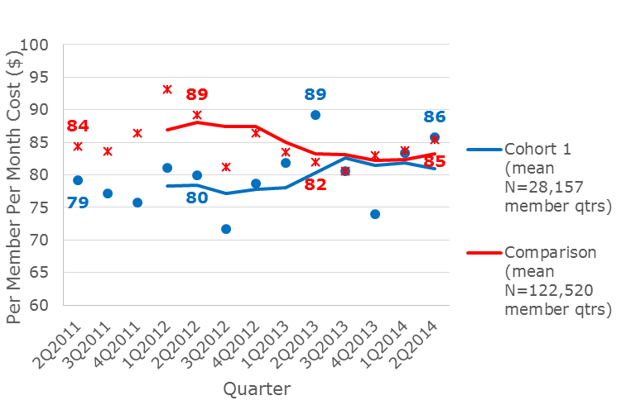
Exhibit 1. Risk-Adjusted Commercial Inpatient PMPM ($) Quarterly Costs for Cohort 1 and Comparison Groups with Rolling Year Trend Line

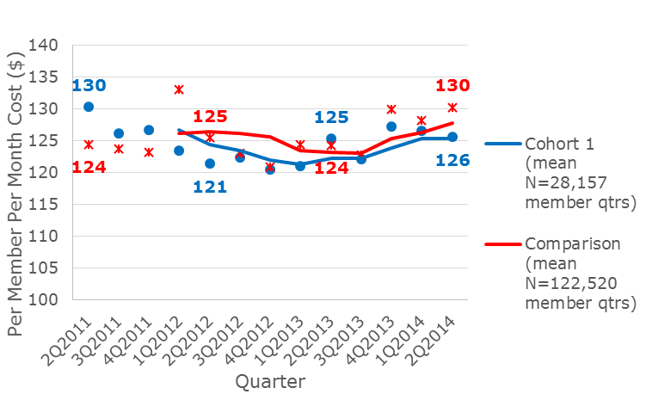
Exhibit 2. Risk-Adjusted Commercial Outpatient PMPM ($) Quarterly Costs for Cohort 1 and Comparison Groups with Rolling Year Trend Line

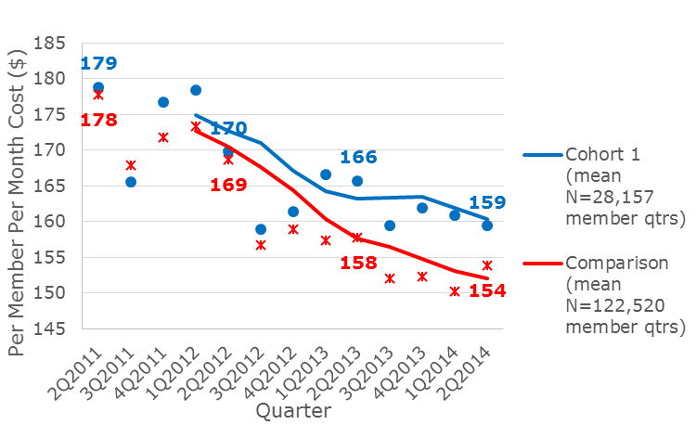
Exhibit 3. Risk-Adjusted Commercial Professional Services PMPM ($) Quarterly Costs for Cohort 1 and Comparison Groups with Rolling Year Trend Line

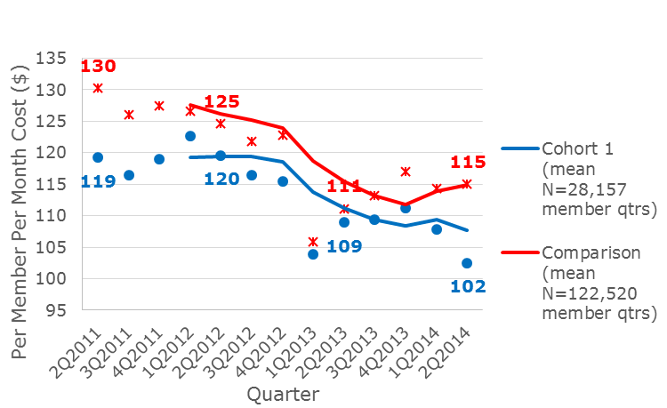
Exhibit 4. Risk-Adjusted Commercial Pharmacy PMPM ($) Quarterly Costs for Cohort 1 and Comparison Groups with Rolling Year Trend Line

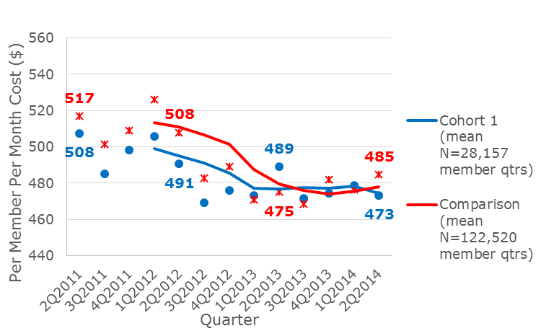
Exhibit 5. Risk-Adjusted Commercial Total PMPM ($) Quarterly Costs for Cohort 1 and Comparison Groups with Rolling Year Trend Line

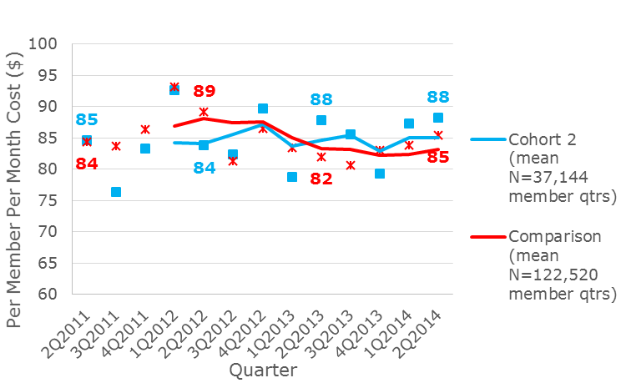
Exhibit 6. Risk-Adjusted Commercial Inpatient PMPM ($) Quarterly Costs for Cohort 2 and Comparison Groups with Rolling Year Trend Line

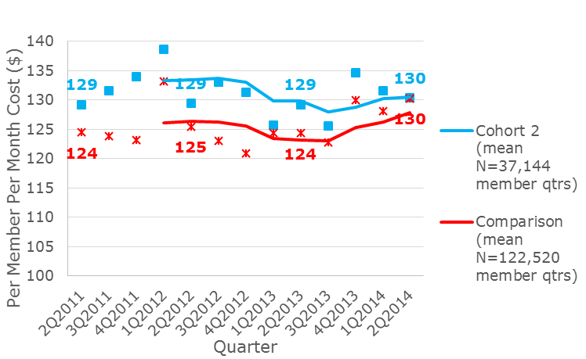
Exhibit 7. Risk-Adjusted Commercial Outpatient PMPM ($) Quarterly Costs for Cohort 2 and Comparison Groups with Rolling Year Trend Line

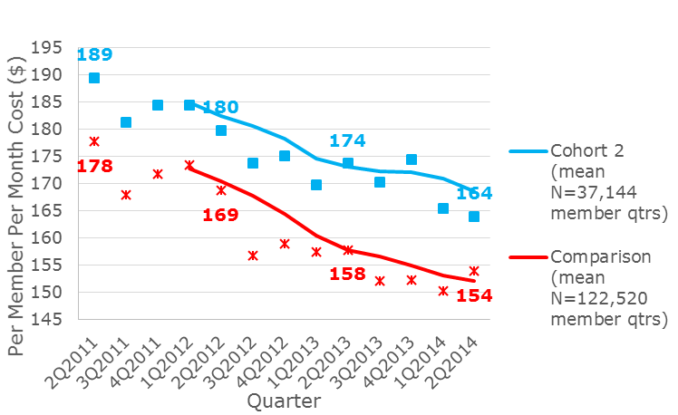
Exhibit 8. Risk-Adjusted Commercial Professional Services PMPM ($) Quarterly Costs for Cohort 2 and Comparison Groups with Rolling Year Trend Line

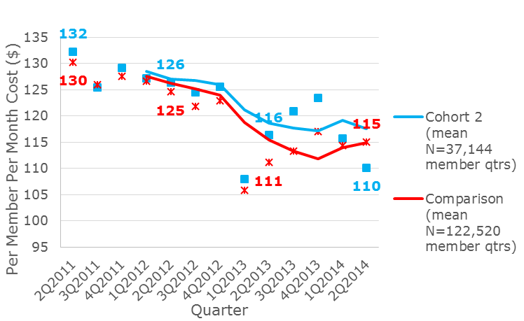
Exhibit 9. Risk-Adjusted Commercial Pharmacy PMPM ($) Quarterly Costs for Cohort 2 and Comparison Groups with Rolling Year Trend Line

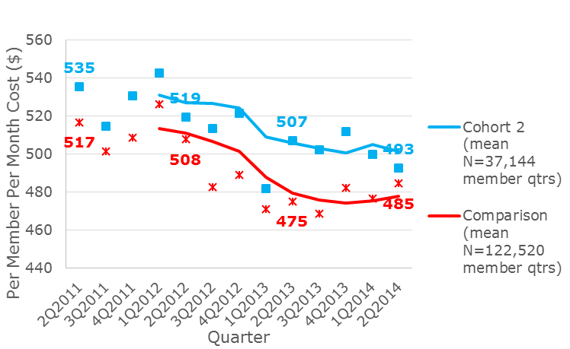
Exhibit 10. Risk-Adjusted Commercial Total PMPM ($) Quarterly Costs for Cohort 2 and Comparison Groups with Rolling Year Trend Line

Medicare Advantage
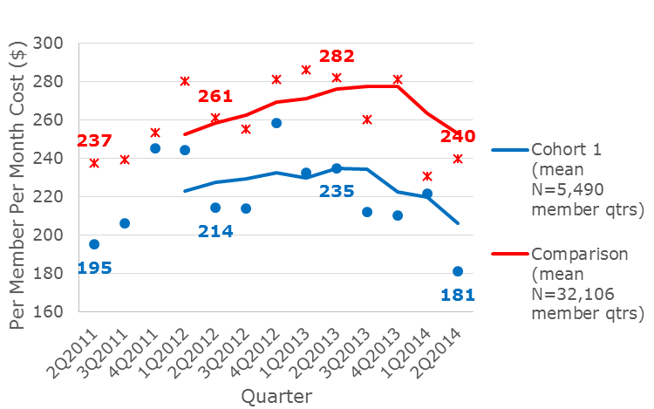
Exhibit 11. Risk-Adjusted Medicare Advantage Inpatient PMPM ($) Quarterly Costs for Cohort 1 and Comparison Groups with Rolling Year Trend Line

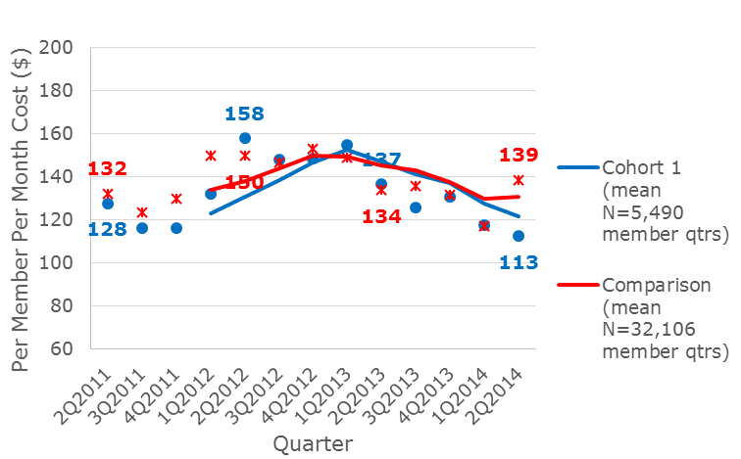
Exhibit 12. Risk-Adjusted Medicare Advantage Outpatient PMPM ($) Quarterly Costs for Cohort 1 and Comparison Groups with Rolling Year Trend Line

Exhibit 13. Risk-Adjusted Medicare Advantage Professional Services PMPM ($) Quarterly Costs for Cohort 1 and Comparison Groups with Rolling Year Trend Line
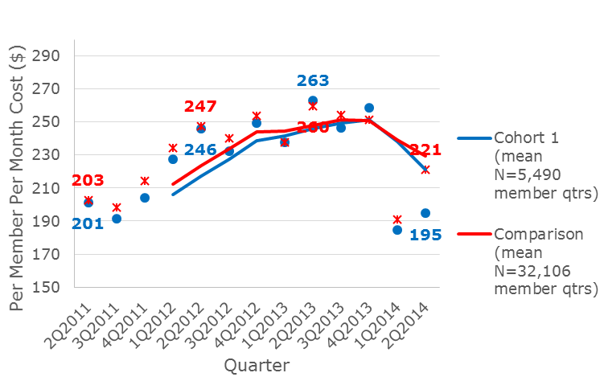

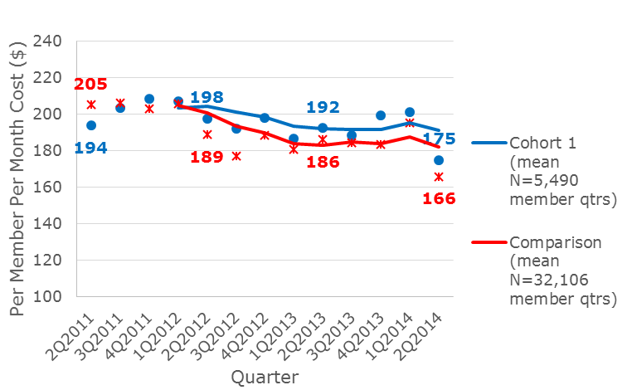
Exhibit 14. Risk-Adjusted Medicare Advantage Pharmacy PMPM ($) Quarterly Costs for Cohort 1 and Comparison Groups with Rolling Year Trend Line

Exhibit 15. Risk-Adjusted Medicare Advantage Total PMPM ($) Quarterly Costs for Cohort 1 and Comparison Groups with Rolling Year Trend Line
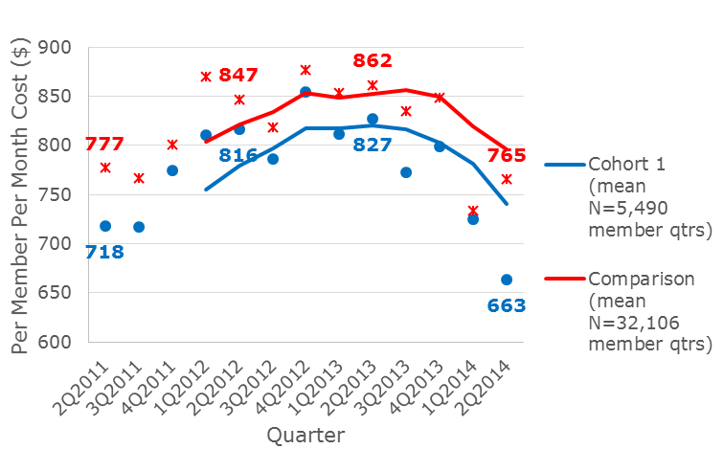

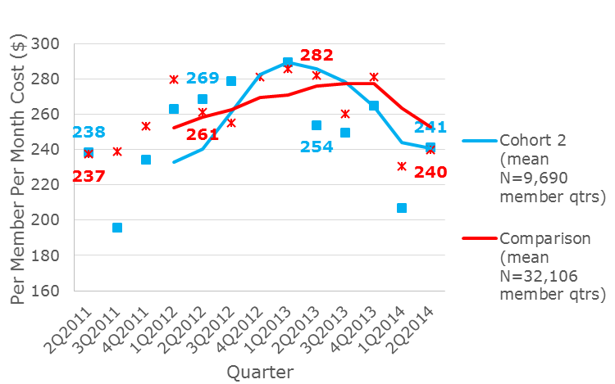
Exhibit 16. Risk-Adjusted Medicare Advantage Inpatient PMPM ($) Quarterly Costs for Cohort 2 and Comparison Groups with Rolling Year Trend Line

Exhibit 17. Risk-Adjusted Medicare Advantage Outpatient PMPM ($) Quarterly Costs for Cohort 2 and Comparison Groups with Rolling Year Trend Line
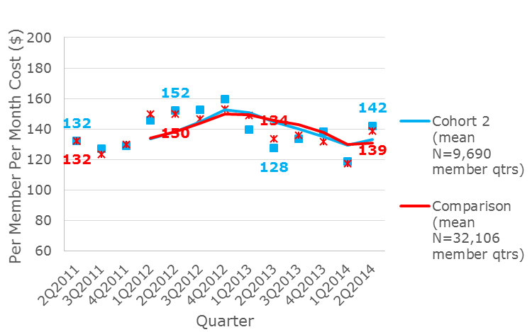

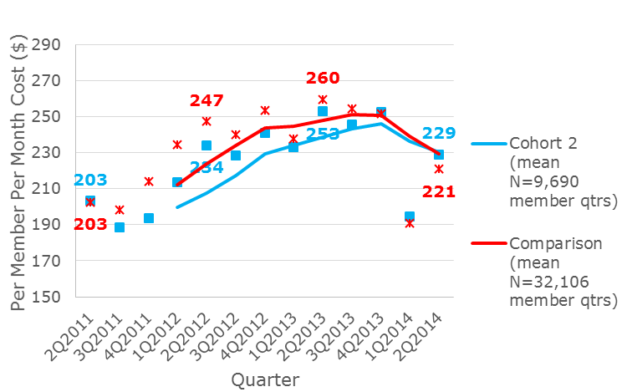
Exhibit 18. Risk-Adjusted Medicare Advantage Professional Services PMPM ($) Quarterly Costs for Cohort 2 and Comparison Groups with Rolling Year Trend Line

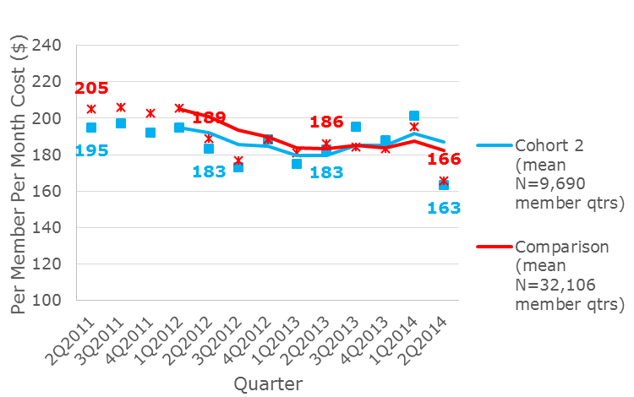
Exhibit 19. Risk-Adjusted Medicare Advantage Pharmacy PMPM ($) Quarterly Costs for Cohort 2 and Comparison Groups with Rolling Year Trend Line

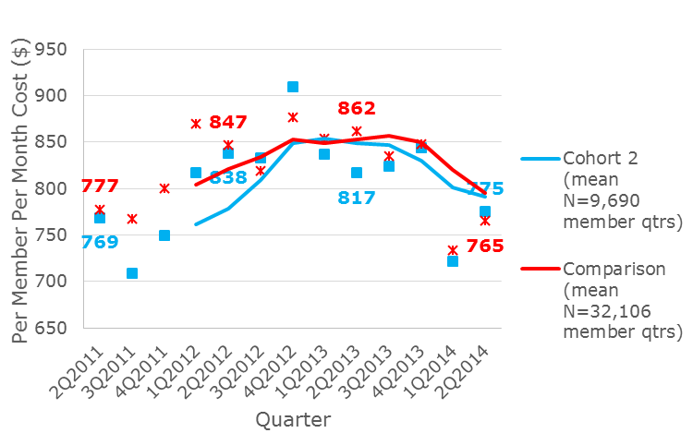
Exhibit 20. Risk-Adjusted Medicare Advantage Total PMPM ($) Quarterly Costs for Cohort 2 and Comparison Groups with Rolling Year Trend Line

Rhody Health Partners
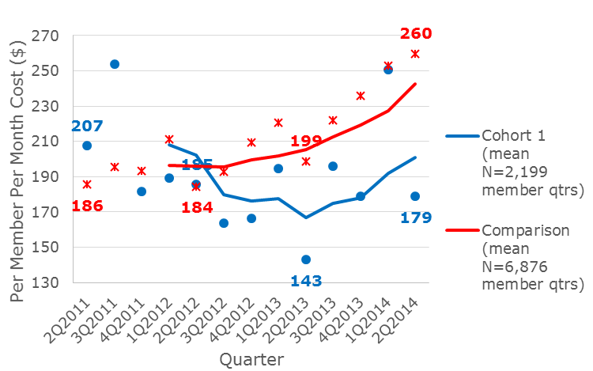
Exhibit 21. Risk-Adjusted RHP Inpatient PMPM ($) Quarterly Costs for Cohort 1 and Comparison Groups with Rolling Year Trend Line

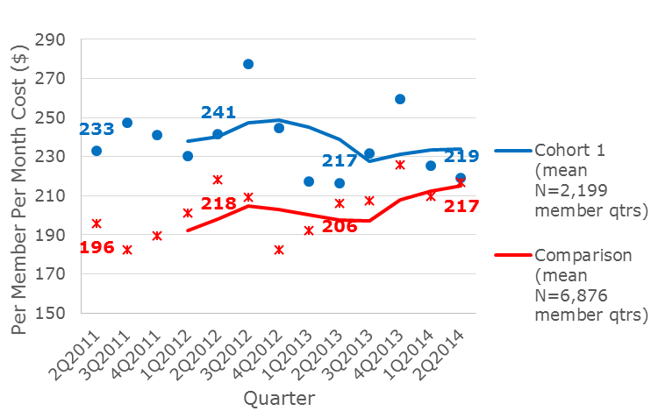
Exhibit 22. Risk-Adjusted RHP Outpatient PMPM ($) Quarterly Costs for Cohort 1 and Comparison Groups with Rolling Year Trend Line

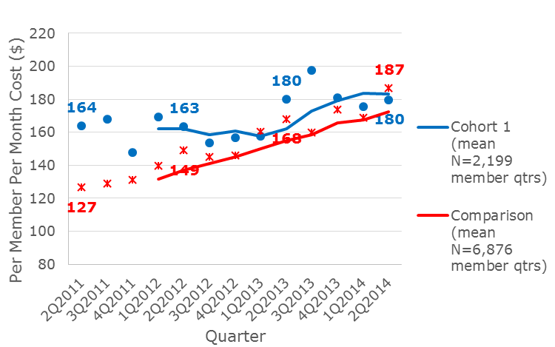
Exhibit 23. Risk-Adjusted RHP Professional Services PMPM ($) Quarterly Costs for Cohort 1 and Comparison Groups with Rolling Year Trend Line

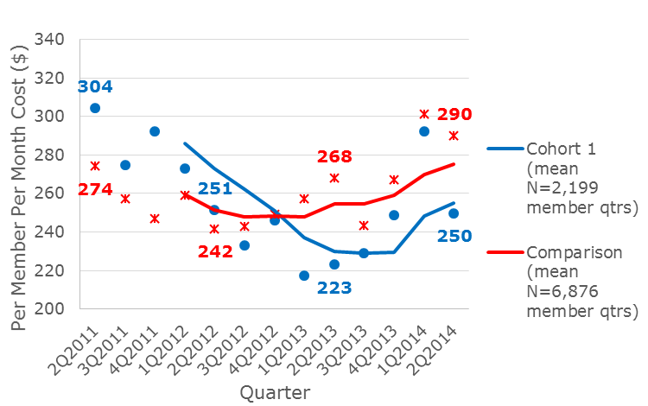
Exhibit 24. Risk-Adjusted RHP Pharmacy PMPM ($) Quarterly Costs for Cohort 1 and Comparison Groups with Rolling Year Trend Line

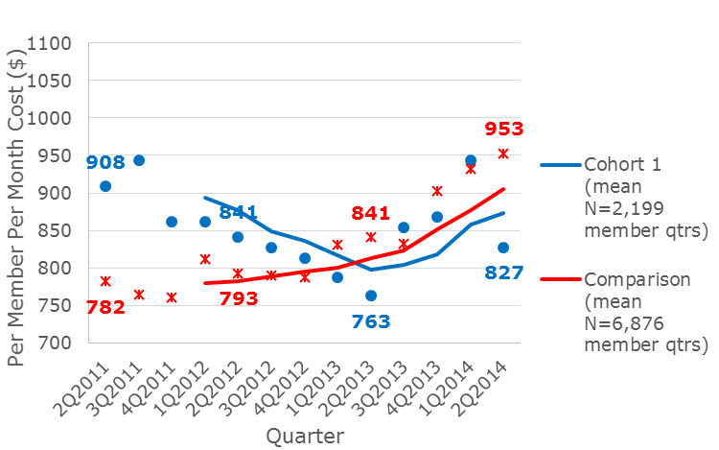
Exhibit 25. Risk-Adjusted RHP Total PMPM ($) Quarterly Costs for Cohort 1 and Comparison Groups with Rolling Year Trend Line

Exhibit 26. Risk-Adjusted RHP Inpatient PMPM ($) Quarterly Costs for Cohort 2 and Comparison Groups with Rolling Year Trend Line
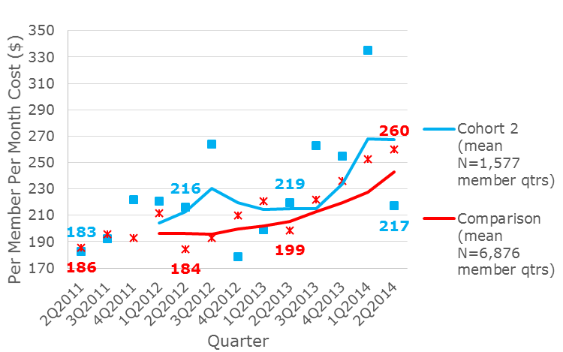

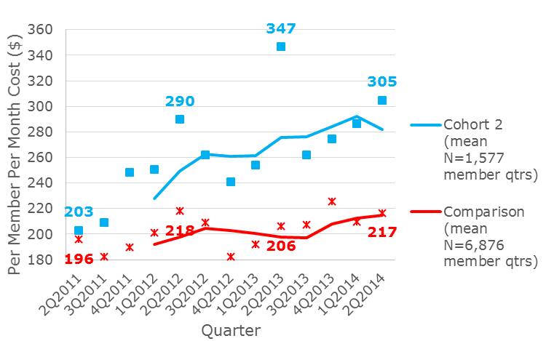
Exhibit 27. Risk-Adjusted RHP Outpatient PMPM ($) Quarterly Costs for Cohort 2 and Comparison Groups with Rolling Year Trend Line

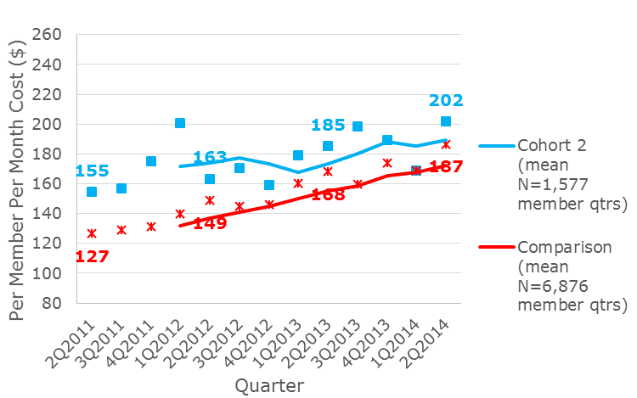
Exhibit 28. Risk-Adjusted RHP Professional Services PMPM ($) Quarterly Costs for Cohort 2 and Comparison Groups with Rolling Year Trend Line

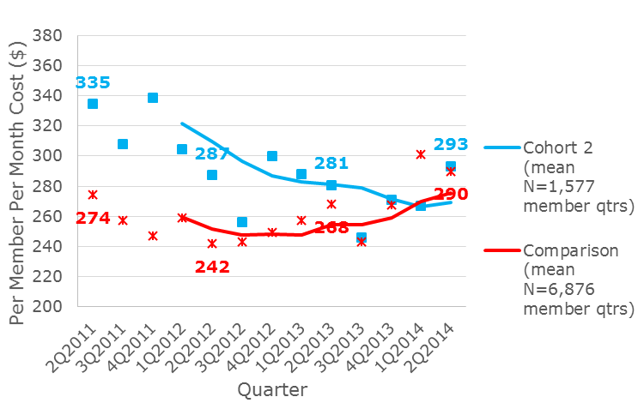
Exhibit 29. Risk-Adjusted RHP Pharmacy PMPM ($) Quarterly Costs for Cohort 2 and Comparison Groups with Rolling Year Trend Line

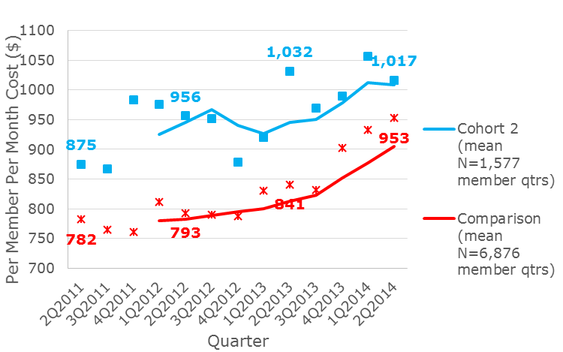
Exhibit 30. Risk-Adjusted RHP Total PMPM ($) Quarterly Costs for Cohort 2 and Comparison Groups with Rolling Year Trend Line

RIteCare
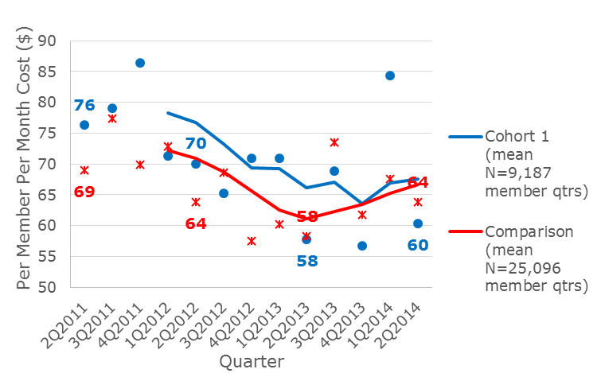
Exhibit 31. Risk-Adjusted RIteCare Inpatient PMPM ($) Quarterly Costs for Cohort 1 and Comparison Groups with Rolling Year Trend Line

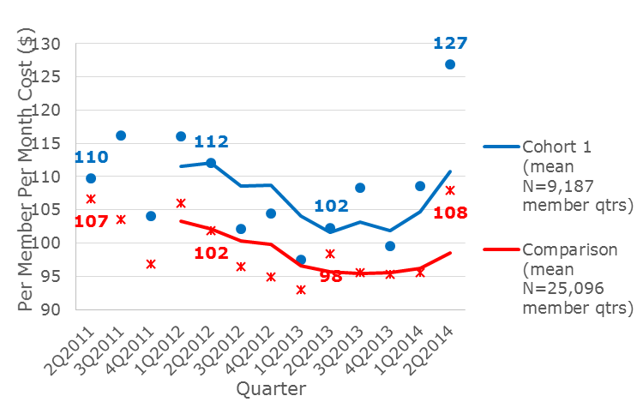
Exhibit 32. Risk-Adjusted RIteCare Outpatient PMPM ($) Quarterly Costs for Cohort 1 and Comparison Groups with Rolling Year Trend Line

Exhibit 33. Risk-Adjusted RIteCare Professional Services PMPM ($) Quarterly Costs for Cohort 1 and Comparison Groups with Rolling Year Trend Line
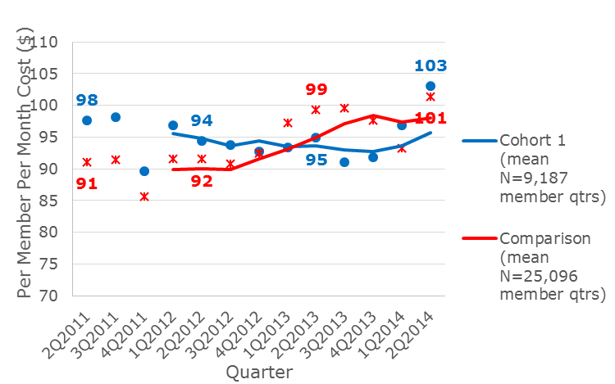

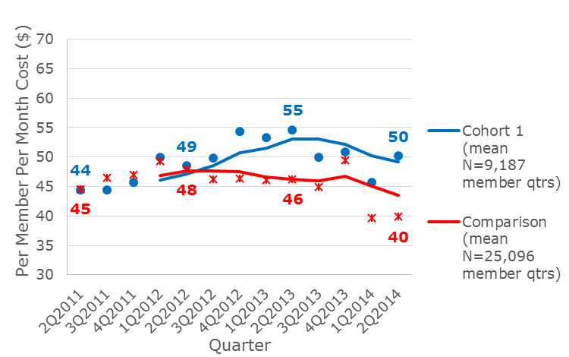
Exhibit 34. Risk-Adjusted RIteCare Pharmacy PMPM ($) Quarterly Costs for Cohort 1 and Comparison Groups with Rolling Year Trend Line

Exhibit 35. Risk-Adjusted RIteCare Total PMPM ($) Quarterly Costs for Cohort 1 and Comparison Groups with Rolling Year Trend Line
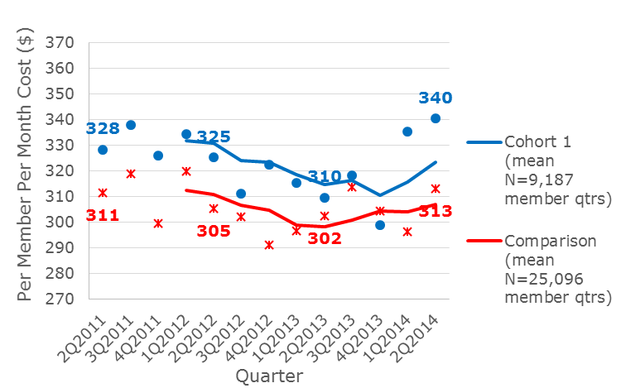

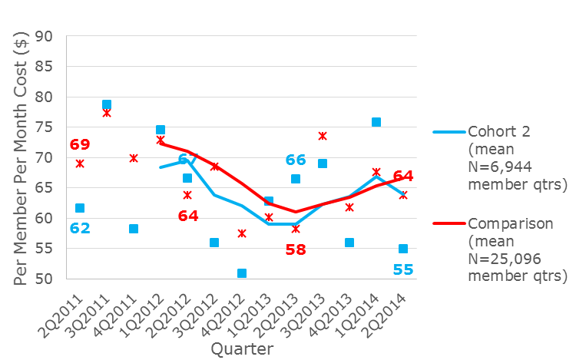
Exhibit 36. Risk-Adjusted RIteCare Inpatient PMPM ($) Quarterly Costs for Cohort 2 and Comparison Groups with Rolling Year Trend Line

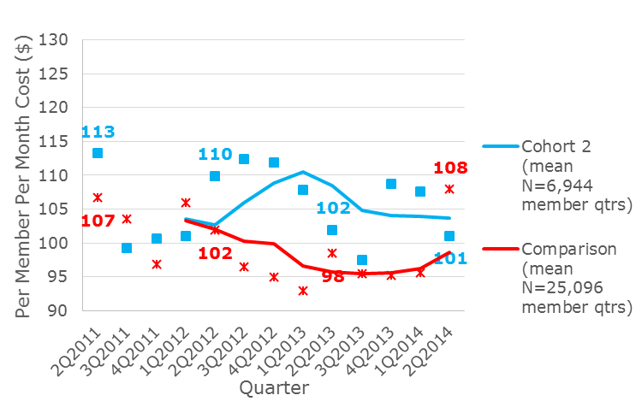
Exhibit 37. Risk-Adjusted RIteCare Outpatient PMPM ($) Quarterly Costs for Cohort 2 and Comparison Groups with Rolling Year Trend Line

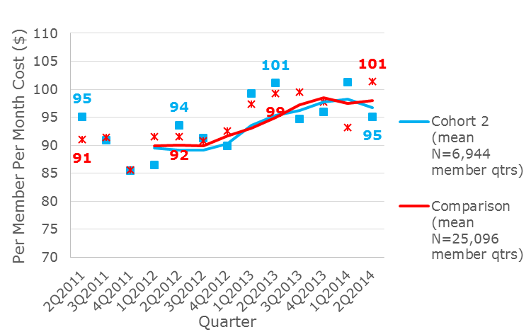
Exhibit 38. Risk-Adjusted RIteCare Professional Services PMPM ($) Quarterly Costs for Cohort 2 and Comparison Groups with Rolling Year Trend Line

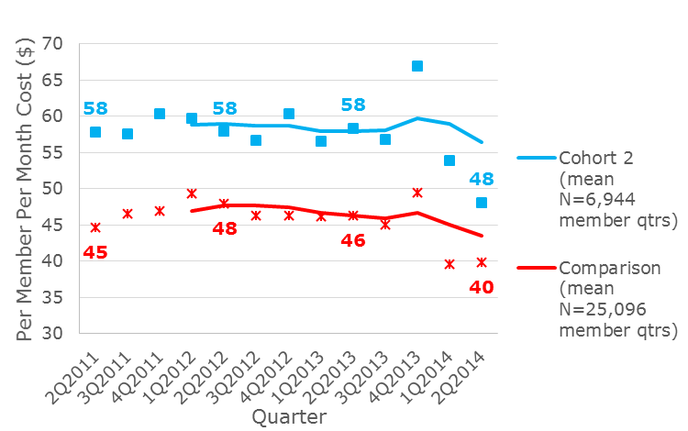
Exhibit 39. Risk-Adjusted RIteCare Pharmacy PMPM ($) Quarterly Costs for Cohort 2 and Comparison Groups with Rolling Year Trend Line

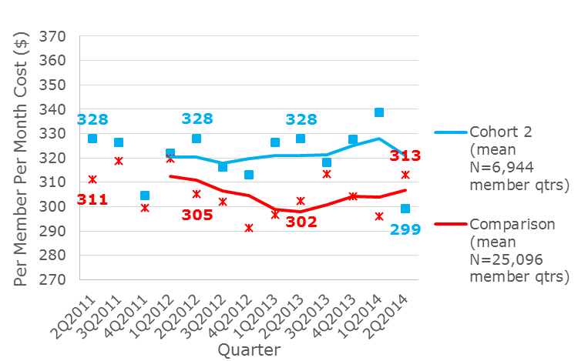
Exhibit 40. Risk-Adjusted RIteCare Total PMPM ($) Quarterly Costs for Cohort 2 and Comparison Groups with Rolling Year Trend Line

Medicare Fee for Service
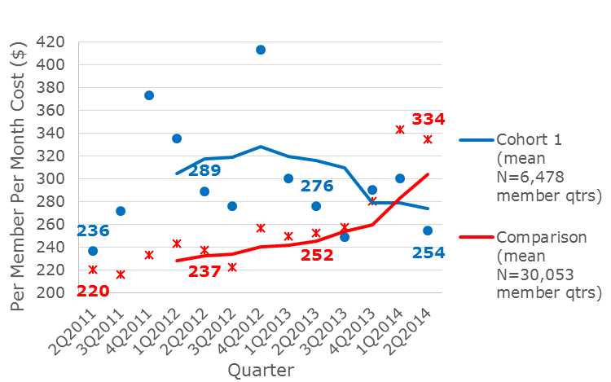
Exhibit 41. Risk-Adjusted Medicare FFS Inpatient PMPM ($) Quarterly Costs for Cohort 1 and Comparison Groups with Rolling Year Trend Line

Exhibit 42. Risk-Adjusted Medicare FFS Outpatient PMPM ($) Quarterly Costs for Cohort 1 and Comparison Groups with Rolling Year Trend Line
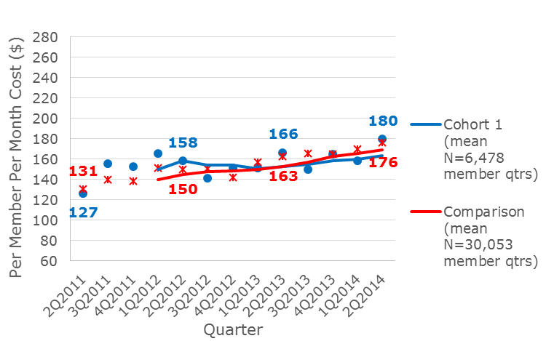
E

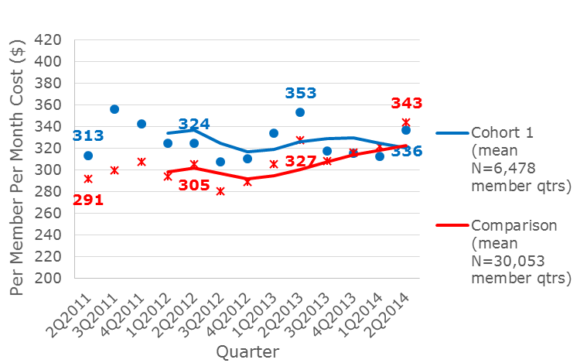
Exhibit 43. Risk-Adjusted Medicare FFS Professional Services PMPM ($) Quarterly Costs for Cohort 1 and Comparison Groups with Rolling Year Trend Line

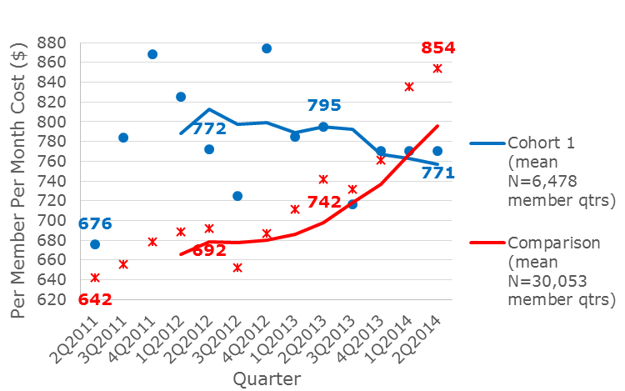
Exhibit 44. Risk-Adjusted Medicare FFS Total PMPM ($) Quarterly Costs for Cohort 1 and Comparison Groups with Rolling Year Trend Line

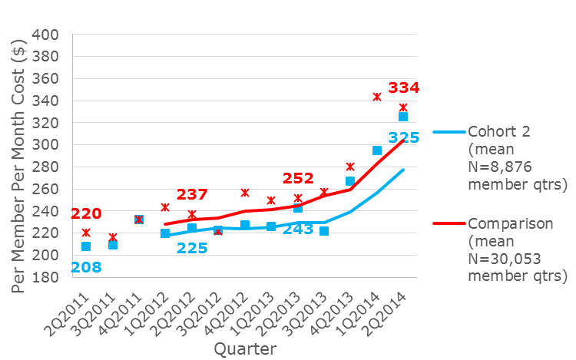
Exhibit 45. Risk-Adjusted Medicare FFS Inpatient PMPM ($) Quarterly Costs for Cohort 2 and Comparison Groups with Rolling Year Trend Line

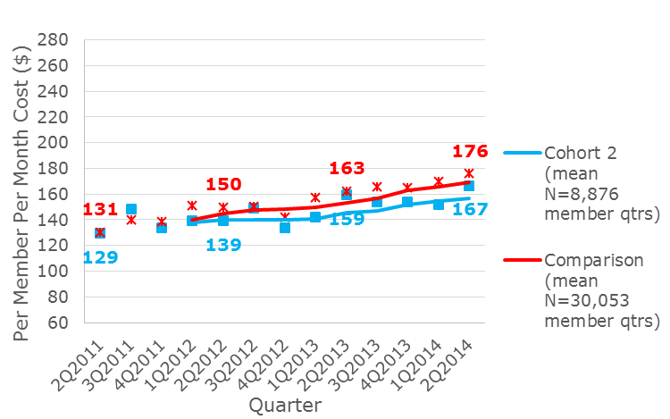
Exhibit 46. Risk-Adjusted Medicare FFS Outpatient PMPM ($) Quarterly Costs for Cohort 2 and Comparison Groups with Rolling Year Trend Line

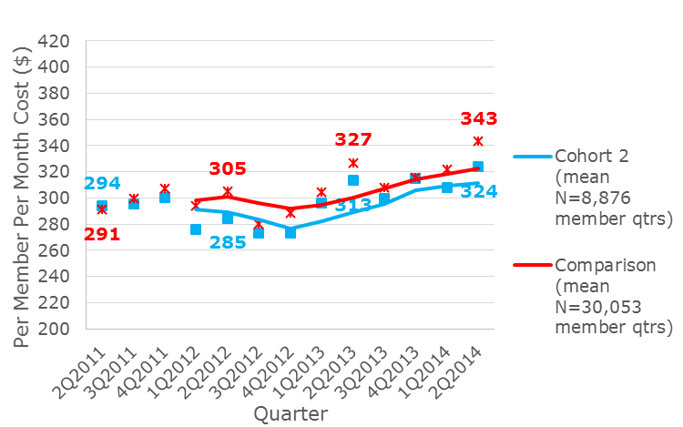
Exhibit 47. Risk-Adjusted Medicare FFS Professional Services PMPM ($) Quarterly Costs for Cohort 2 and Comparison Groups with Rolling Year Trend Line

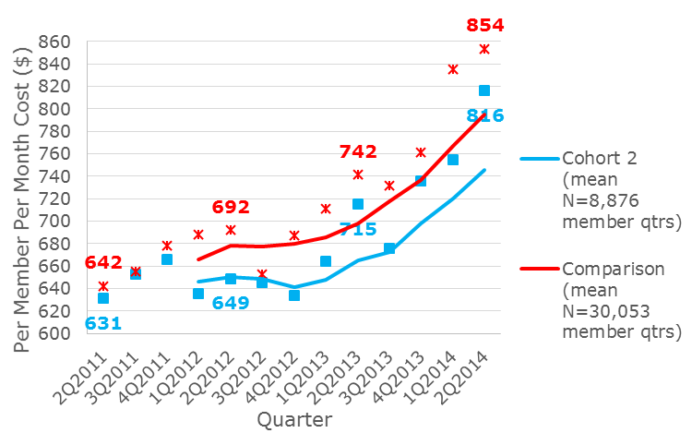
Exhibit 48. Risk-Adjusted Medicare FFS Total PMPM ($) Quarterly Costs for Cohort 2 and Comparison Groups with Rolling Year Trend Line

Medicaid Fee for Service
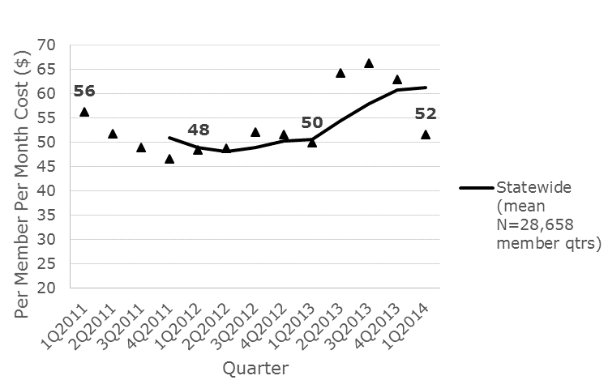
Exhibit 49. Risk-Adjusted Medicaid FFS Inpatient PMPM ($) Quarterly Costs with Rolling Year Trend Line

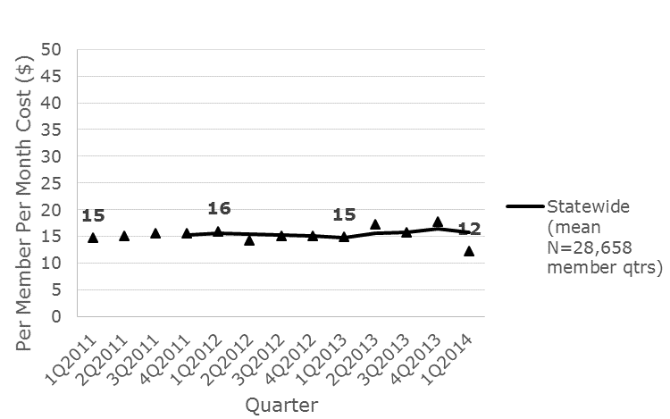
Exhibit 50. Risk-Adjusted Medicaid FFS Outpatient PMPM ($) Quarterly Costs with Rolling Year Trend Line

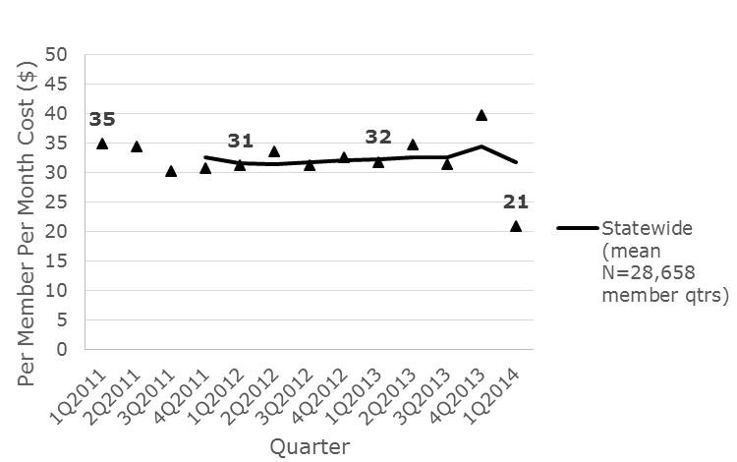
Exhibit 51. Risk-Adjusted Medicaid FFS Professional Services PMPM ($) Quarterly Costs with Rolling Year Trend Line

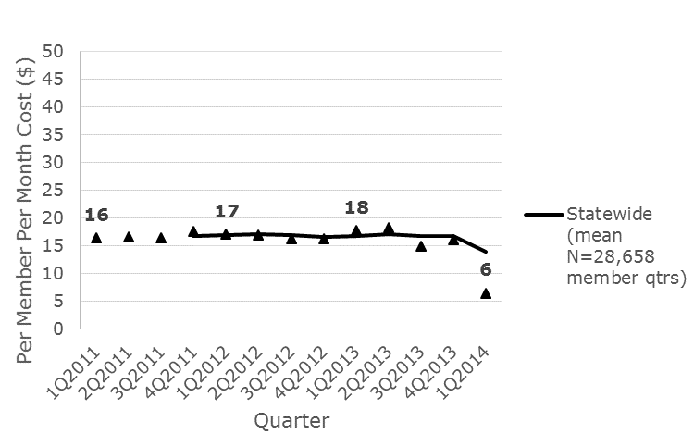
Exhibit 52. Risk-Adjusted Medicaid FFS Pharmacy PMPM ($) Quarterly Costs with Rolling Year Trend Line

Exhibit 53. Risk-Adjusted Medicaid FFS Total PMPM ($) Quarterly Costs with Rolling Year Trend Line
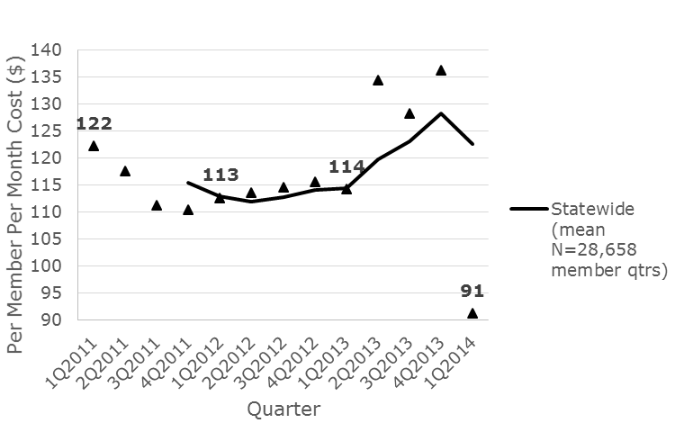

Costs for Medicaid FFS are only available through March 2014.
Costs covered by Medicaid FFS when the member is also covered by RIteCare (crossover claims) are not included in the costs since the member would be double counted. Only claims where a member is only covered by Medicaid FFS are included in the PMPM costs. Claims for members who are dually eligible (for Medicaid and Medicare) are not included in the PMPM costs.
Only statewide estimates are shown due to small numbers of members being attributed.
Number of member quarters during 2011 is 97,656; 2012 is 113,099; 2013 is 116,637; 1Q-2Q2014 is 59,868.
Number of member quarters during 2011 is 456,548; 2012 is 501,443; 2013 is 500,238; 1Q-2Q2014 is 238,598.
Total costs are a sum of the individual inpatient, outpatient, professional services and pharmacy PMPM.
Number of member quarters during 2011 is 132,688; 2012 is 150,181; 2013 is 152,224; 1Q-2Q2014 is 76,849.
Number of member quarters during 2011 is 456,548; 2012 is 501,443; 2013 is 500,238; 1Q-2Q2014 is 238,598.
Total costs are a sum of the individual inpatient, outpatient, professional services and pharmacy PMPM.
Number of member quarters during 2011 is 20,200; 2012 is 21,387; 2013 is 23,029; 1Q-2Q2014 is 11,698.
Number of member quarters during 2011 is 125,882; 2012 is 131,929; 2013 is 129,312; 1Q-2Q2014 is 61,542.
Total costs are a sum of the individual inpatient, outpatient, professional services and pharmacy PMPM.
Number of member quarters during 2011 is 36,654; 2012 is 39,155; 2013 is 39,717; 1Q-2Q2014 is 19,485.
Number of member quarters during 2011 is 125,882; 2012 is 131,929; 2013 is 129,312; 1Q-2Q2014 is 61,542.
Total costs are a sum of the individual inpatient, outpatient, professional services and pharmacy PMPM.
Number of member quarters during 2011 is 7,456; 2012 is 8,531; 2013 is 9,474; 1Q-2Q2014 is 4,830.
Number of member quarters during 2011 is 27,103; 2012 is 28,137; 2013 is 27,880; 1Q-2Q2014 is 12,949.
Total costs are a sum of the individual inpatient, outpatient, professional services and pharmacy PMPM.
Number of member quarters during 2011 is 5,601; 2012 is 6,304; 2013 is 6,601; 1Q-2Q2014 is 3,318.
Number of member quarters during 2011 is 27,103; 2012 is 28,137; 2013 is 27,880; 1Q-2Q2014 is 12,949.
Total costs are a sum of the individual inpatient, outpatient, professional services and pharmacy PMPM.
Number of member quarters during 2011 is 27,044; 2012 is 31,675; 2013 is 35,747; 1Q-2Q2014 is 31,194.
Number of member quarters during 2011 is 88,124; 2012 is 91,339; 2013 is 91,259; 1Q-2Q2014 is 77,238.
Total costs are a sum of the individual inpatient, outpatient, professional services and pharmacy PMPM.
Number of member quarters during 2011 is 21,439; 2012 is 23,440; 2013 is 24,851; 1Q-2Q2014 is 25,673.
Number of member quarters during 2011 is 88,124; 2012 is 91,339; 2013 is 91,259; 1Q-2Q2014 is 77,238.
Total costs are a sum of the individual inpatient, outpatient, professional services and pharmacy PMPM.
Dual eligible members are not included.
Number of member quarters during 2011 is 22,561; 2012 is 24,873; 2013 is 27,723; 1Q-2Q2014 is 14,367.
Number of member quarters during 2011 is 112,364; 2012 is 119,059; 2013 is 125,111; 1Q-2Q2014 is 61,247.
Total costs are a sum of the individual inpatient, outpatient, and professional services PMPM.
Dual eligible members are not included.
Number of member quarters during 2011 is 29,609; 2012 is 34,243; 2013 is 38,273; 1Q-2Q2014 is 20,130.
Number of member quarters during 2011 is 112,364; 2012 is 119,059; 2013 is 125,111; 1Q-2Q2014 is 61,247.
Total costs are a sum of the individual inpatient, outpatient, and professional services PMPM.
Costs for wrap-around services provided for managed care enrollees are not included.
Only statewide estimates are shown due to small numbers of members being attributed. Number of member quarters during 2011 is 130,570; 2012 is 119,126; 2013 is 90,206; 1Q2014 is 32,658.
Total costs are a sum of the individual inpatient, outpatient, professional services and pharmacy PMPM.
Claims with any line item having a revenue code of 112 122 132 142 152 232, or 720-729.

