Growing Access to Patient-Centered Medical Homes
Across Rhode Island
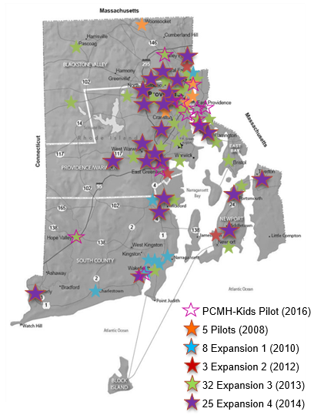
In 2015, our Collaborative supported the delivery of high-quality patient-centered care across more communities in Rhode Island.

- 73 adult primary care practice sites
- 9 pediatric pilot practices
- Nearly 522 providers across our adult and pediatric practices
- Supporting patient-centered medical homes in 26 cities and town
- More than 300,000 adult patients
- 30,000 pediatric patients
- Includes all R.I. Federally Qualified Health Centers

- Affinity Arcand Family Medicine
- Affinity Brookside Family Medicine
- Affinity Primary Medical Group of Warwick
- Affinity-Family Medicine at Women’s Care
- Anchor Medical Associates (Lincoln, Providence, Warwick)
- Anchor Medical Associates Pediatrics
- Associates in Primary Care Medicine
- Barrington Family Medicine
- Blackstone Valley Community Health Center (Central Falls and Pawtucket)
- Charter Care Medical Associates
- Coastal Medical (East Providence, Narragansett, Pawtucket (Hillside), Providence, and Wakefield)
- Coastal Narragansett Bay Pediatrics
- Coastal Waterman Pediatrics
- Comprehensive Community Action Program (Cranston, Coventry, Warwick)
- Coventry Primary Care Associates
- East Bay Community Action Program (East Providence, Newport)
- East Greenwich Pediatrics
- Family Health and Sports Medicine

- Hasbro Pediatric Primary Care
- Hasbro Medicine-Pediatric Primary Care Clinic
- Internal Medicine Partners
- John Chaffey, DO, Ltd.
- Kristine Cunniff, MD
- Medical Associates of Rhode Island (Barrington and Bristol)
- Memorial Hospital Family Care Center
- Memorial Hospital Internal Medicine Center
- Nardone Medical Associates
- North Kingstown Family Practice
- Ocean State Medical
- Pediatric Associates
- Primary Care of Barrington
- Providence Community Health Centers (Capitol Hill, Central, Chad Brown, Chafee, Crossroads, North Main St., Olneyville, and Prairie Ave.)
- Richard Del Sesto, MS, MD, Ltd.
- Solmaz Behtash, DO
- SouthCoast Health System Linden Tree Health Center
- SouthCoast Health System Tiverton Family Practice
- SouthCoast Health System Family Medical Middletown
- SouthCoast Health System Family MediCenter
- South County Hospital Family Medicine
- South County Hospital Primary Care and Internal Medicine (Wakefield and Westerly)
- South County Internal Medicine
- South County Walk-In and Primary Care
- Stuart Demirs, MD
- Thundermist Health Center (Wakefield, West Warwick, Woonsocket)
- Tri-Town Community Action Program
- University Family Medicine
- University Internal Medicine
- University Medicine (Pawtucket, Governor St., North Main St., East Ave., East Providence, Plain St., Warwick)
- University Medicine-Aquidneck Medical Associates (Newport and Portsmouth)
- WellOne Primary Medical and Dental Care (Foster, North Kingstown, and Pascoag)
- Wickford Family Medicine
- Women’s Primary Care, Women’s Medicine Collaborative
- Wood River Health Services (Hope Valley)

